Online Permit Center
Training Document
Prepared for: | Prepared by:
County of San Mateo

Abbreviations
Abbreviation | Definition
Portal | Online Permit Center https://aca-prod.accela.com/SMCGOV/Default.aspx
System | Accela Government Software

ACA How to create a Registered User

Description
  - In order to be able to apply for a permit, you must first register on Portal. Below steps provide guidance on this process.

Steps
 | On Portal, click ‘Register for an Account. | 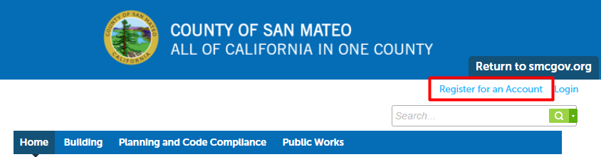
 | Check the checkbox and click ‘Continue Registration’. | 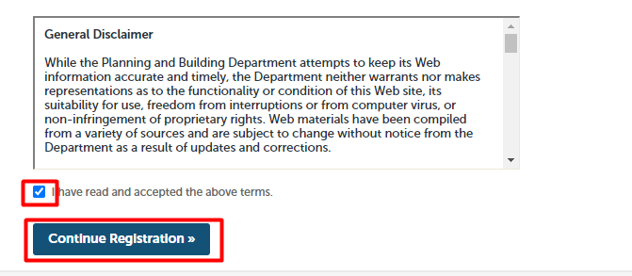
 | Fill out the required fields under ‘Login Information’. | 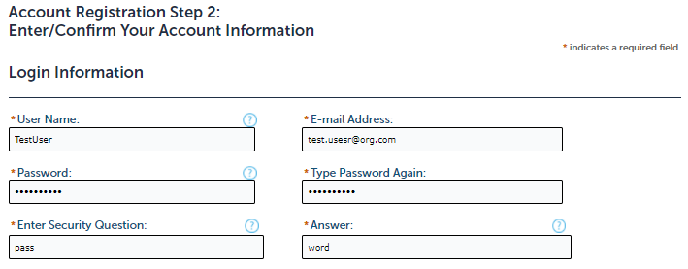
 | Click ‘Add New’ under ‘Contact Information’. | 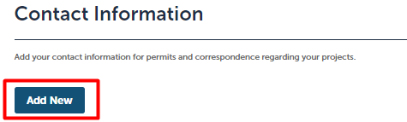
 | Select the applicable ‘Type’ and click ‘Continue’. | 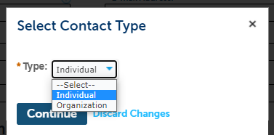
 | Fill out the required fields under ‘Contact Information’ and click ‘Continue’. | 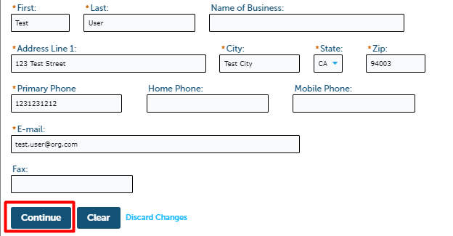
 | Click ‘Continue Registration’ at the bottom of the page. | 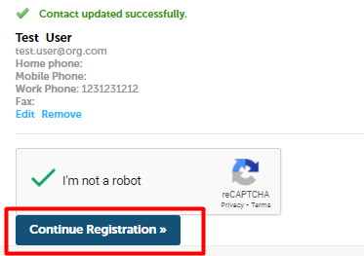
 | System provides a success message. You may now login via clicking ‘Login’ and entering your user and password. | 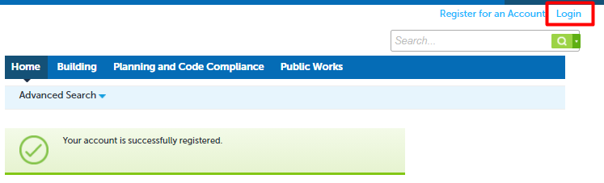

ACA How to look up property information

Description
  - Portal provides ability to look up property information via Advanced Search and Application process. Please see below steps for guidance.

Steps
- Via Advanced Search
 | On Portal, go to Advanced Search à Search Records/Applications and select the required option. | 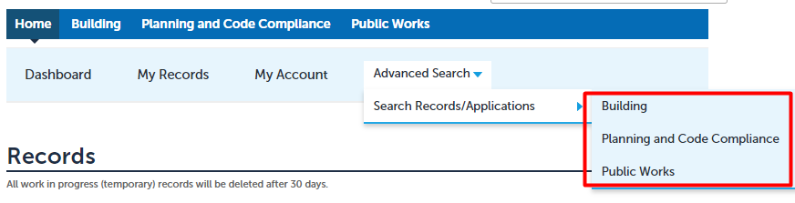
 | Under ‘General Search’, fill out the search form and click ‘Search’.  You can search by entering either of the date, address, parcel number or permit number. | 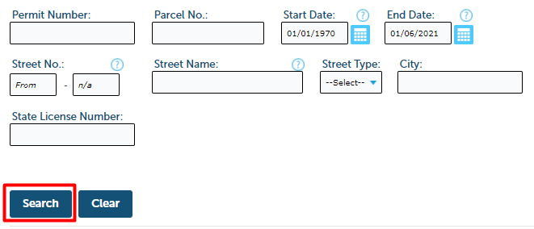
 | The list of the properties will appear below the search form. | 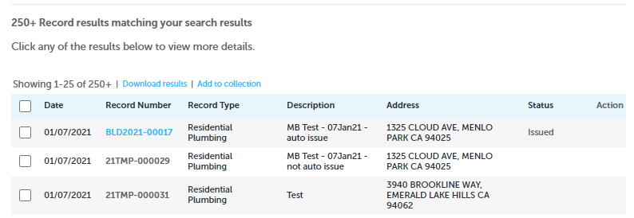

- Via Application
 | On Portal, click ‘Apply for Permit’. | 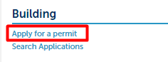
 | Check the checkbox and click ‘Continue Application’. | 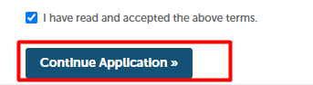
 | Select applicable record type and click ‘Continue Application’. | 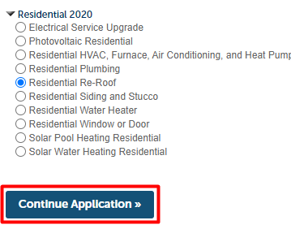
 | Under ‘Address’, fill out the search form and click ‘Search’. Alternately, you can search by entering parcel or owner information. | 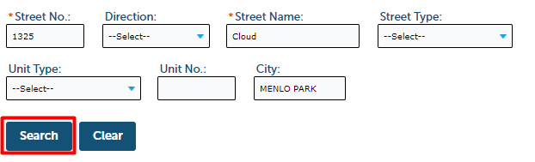
 | System opens ‘Address Search Result List’ pop-up window. Click on radio button next to the required address. | 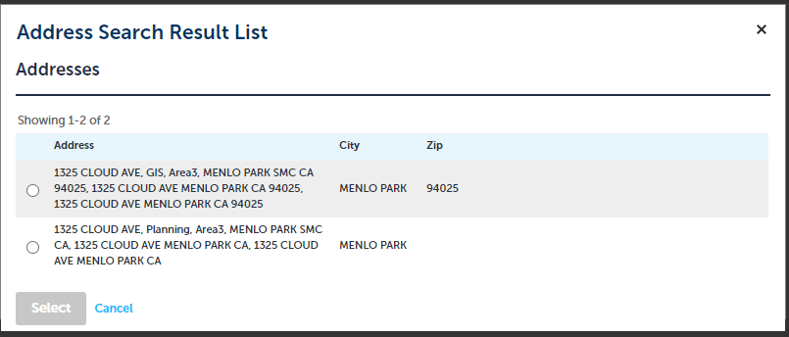
 | System updates ‘Address Search Result List’, providing associated parcels and owners list. | 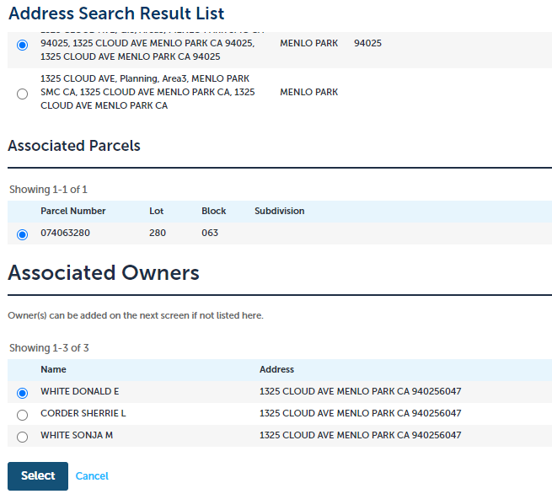

ACA How to search for a licensed contractor

Description
  - When applying for a permit, you may be asked to add a licenced professional to your application. Below steps provide guidance on how to look up the list of professionals in the system.

Steps
 | On Portal – Application page, click ‘Search’ under ‘Licensed Professional’ section. | 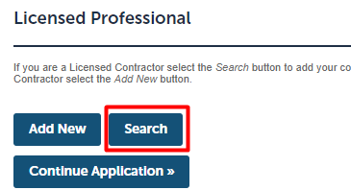
 | System provides ‘Look Up Licence’ pop-up window. Fill out the form by entering known information and .click ‘Look Up’. | 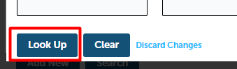
 | System displays list of records that match provided search requirements. Y may browse and pick required record and click ‘Continue’ to select the record for Application. | 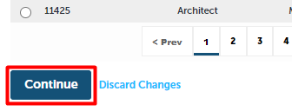

ACA How to pay fees Description

Description
  - When applying for a permit, you may be asked to pay fees. Below steps provide guidance on how to pay the fees before application can be submitted.

Steps
 | On Portal, Application page – ‘Pay Fees’ tab, click ‘Continue Application’. | 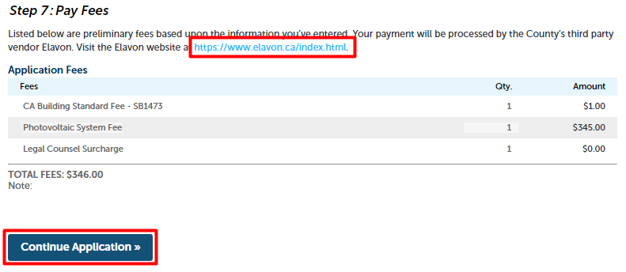
 | System opens ‘Payment Options’ page. Enter required payment information and click ‘Submit Payment’. | 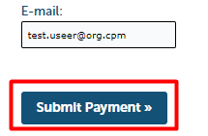

ACA How to upload attachments after application submitted

Description
  - Portal allows to attach applications to the record before and after the application is submitted. Below steps provide guidance on how to attach documents to a record when application has already been submitted.

Steps
 | On Portal, find your Application via either the Search field or ‘My Records’ page | 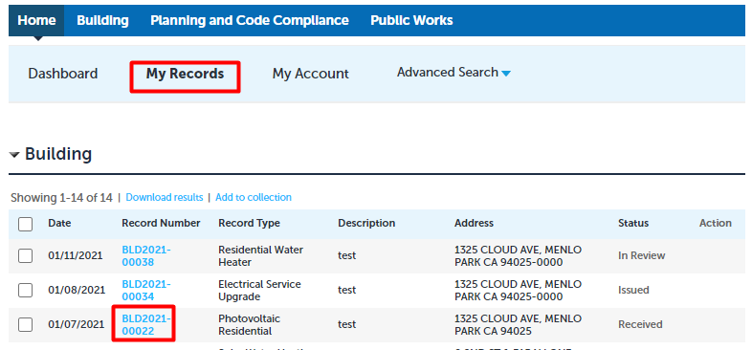
 | When on Application page, go to Record Info à Attachments | 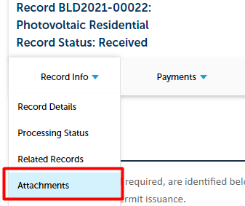
 | System opens ‘Attachments’ page. Click ‘Add’ at the bottom of the page. | 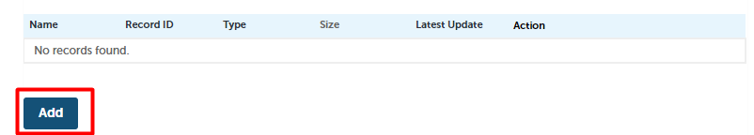
 | System opens ‘File Upload’ pop up window. Click ‘Add’ for the file selection. | 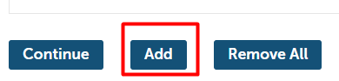
 | System opens Windows Explorer with files on your machine. Select one or more required files and lick ‘Continue’ | 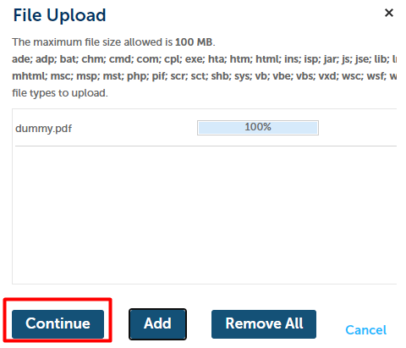
 | System displays preview of the files to be uploaded. Fill out the required ‘Description’ fields and click ‘Save’.
 | System displays list of the uploaded files. You may view details or delete the uploaded file via Actions à View Details/Delete next to each row. You may also add new files via ‘Add’ button. | 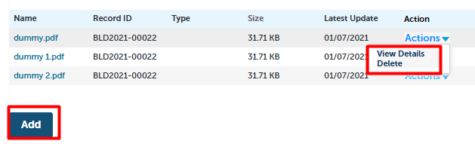

ACA List of documents to upload, by permit

Description
For most permit’s documents will be required to be loaded up prior to submission. The only OTC permit that does not require documents is the water heater permit. Documents will be required depending on the value of the data fields or location of the property. The list of scenarios is provided in the section below. Also, the information provided on the document page will provide this list of required documents depending on permit and scenario.

List of documents
 | Electrical Service Upgrade | If the data field Is the service upgrade less than 300 Amps = No then you will need the document Load Calculations | LOAD
 | Residential HVAC, Furnace, Air Conditioning, and Heat Pump | If the data field Furnace - Is the appliance located in the lower level (basement or crawlspace) = Yes and the fuel type is propane then you will need the document Cross Sectional Plan (propane fueled furnaces located in basements) | CROSS  If the data field AC - Is the appliance located in the lower level (basement or crawlspace) = Yes and the fuel type is propane then you will need the document Cross Sectional Plan (propane fueled furnaces located in basements) | CROSS  If the data field AC is checked then you will need the documents Air Conditioning Unit Site Plan | AC and Manufacturer Specification | MSPEC  If the data field Heat Pulp = Yes then you will need the document Heat pump floor plan | HEAT  If the data field Furnace - Is the installation or replacement located in the garage = Yes then you will need the document Floor Plan | FLOOR
 | Residential Plumbing | If the data field Sewer is checked then no documents are required  If the data field Water is checked and the data field New, Replacement, or No Meter Change = New then you will need the document Will Serve Letter | WSL  If the data field Gas is checked and the data field Is the gas line running into a dedicated appliance = No then you will need the document Schematics | SCHEM
 | Residential Re-Roof | If within a coastal or design review district, then you will need the document Roof Colors | COLOR
 | Residential Siding and Stucco | If within a coastal or design review district and the data field For partial siding/stucco replacement, does the new match existing colors and materials? = No then you will need the document Colors/Finish and Materials | COLOR  If within a coastal or design review district and the data field For partial siding/stucco replacement, does the new match existing colors and materials? = Yes then you will need the document Photos of Existing Siding or Stucco | PHOTO
 | Residential Water Heater | If the replacement water heater is not in the same location and will be located in the garage then you will need the document Floor Plan | FLOOR
 | Residential Window or Door | If within a coastal or design review district, then you will need the document Colors/Finish and Materials | COLOR

ACA How to Apply for a Permit

Description
Applying for a Permit includes submitting Application Form and providing relevant information and documentation.
Each Permit Type may require different type of information to be provided. Colors/Finish and Materials | COLOR

Steps
 | On Portal, click ‘Apply for Permit’.
 | Read and accept the General disclaimer by checking the checkbox and click ‘Continue Application’.
 | Select applicable record type and click ‘Continue Application’. |  | 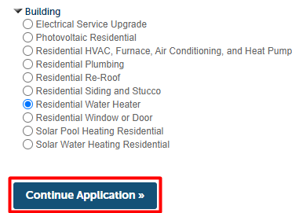
 | System opens Application Form with tabs, specific to the type selected in the previous step. Start providing information under each tab.  You may click ‘Save and resume later’ to safe provided information and continue filling out the form later. |  | 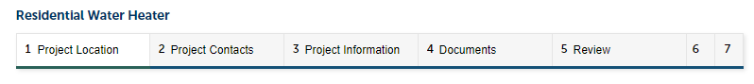
 | Unde ‘Location’ – ‘Address’, fill out the search form and click ‘Search’. Alternately, you can search by entering parcel or owner information.
 | System opens ‘Address Search Result List’ pop-up window. Click on radio button next to the required address.
 | System updates ‘Address Search Result List’, providing associated parcels and owners list.  Pick the applicable parcels and owners and click ‘Select’. |  | 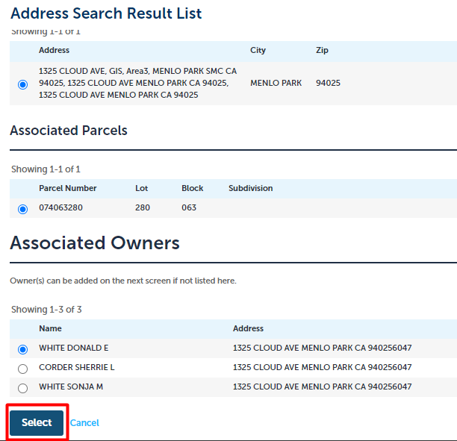
 | Once System populated the selected information under ‘Location’ tab, click ‘Continue Application’. |  | 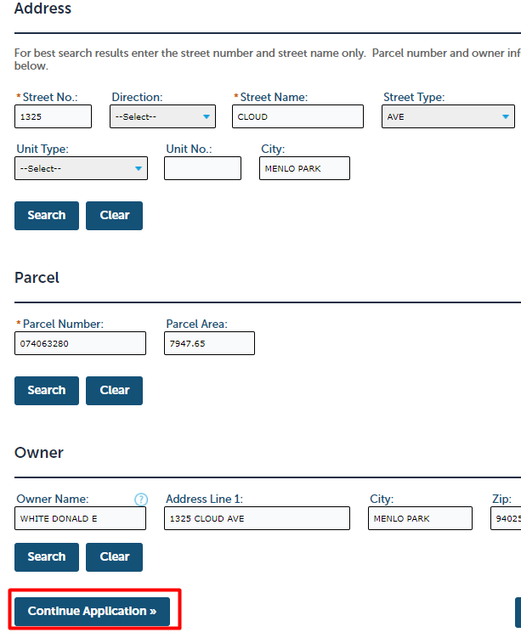
 | Under ‘Project Contacts’ tab add Applicant information. You can click ‘As Applicant’ to add existing user e.g. yourself. You can also click ‘Add New’ to add new person.  If you prefer to ‘Add New’ person, go to step #14. |  | 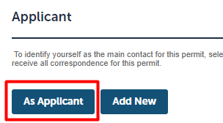
 | Once you click ‘As Applicant’, System displays ‘Select Contact from Account’ pop-up window. Select applicable contact and click ‘Continue’. |  | 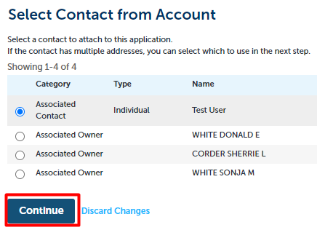
 | System displays added Applicant.  You may click ‘Edit’ to update user information or click ‘Remove’ to remove the Applicant and add different one. |  | 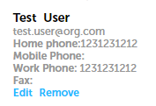
 | If you wish to add new person instead, under ‘Project Contacts’ tab click ‘Add New’ to add new person. |  | 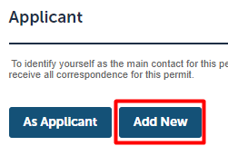
 | System opens ‘Contact Information’ pop up. Fill out the required fields and click ‘Continue’. |  | 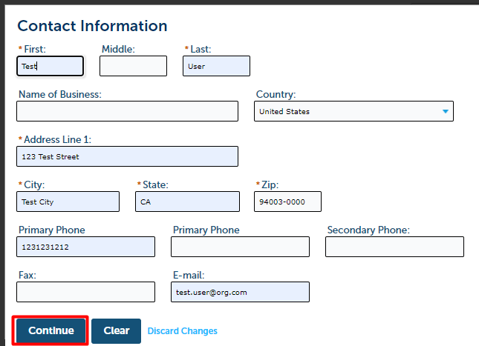
 | System displays added Applicant.  You may click ‘Edit’ to update user information or click ‘Remove’ to remove the Applicant and add different one. |  | 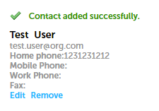
 | Under ‘Project Contacts’ – ‘Owner/Builder’, click ‘As Applicant’ and then ‘Continue Application’ if you are the owner and assuming General Contractor responsibilities for this project. Otherwise, only click continue Application. |  | 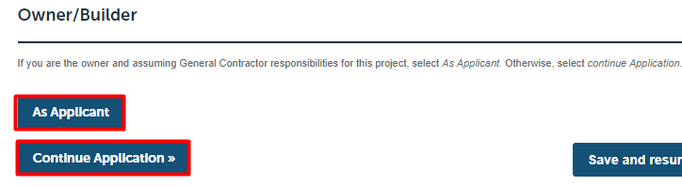
 | System opens ‘Licenced Contractor and Professional List’. Click ‘Add New’ to add a new person. If you wish to search in the System, go to step #20. |  | 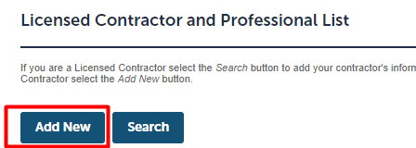
 | System opens ‘Licensed Professional Information’ pop up. Fill out the required fields and click ‘Save and Close’. |  | 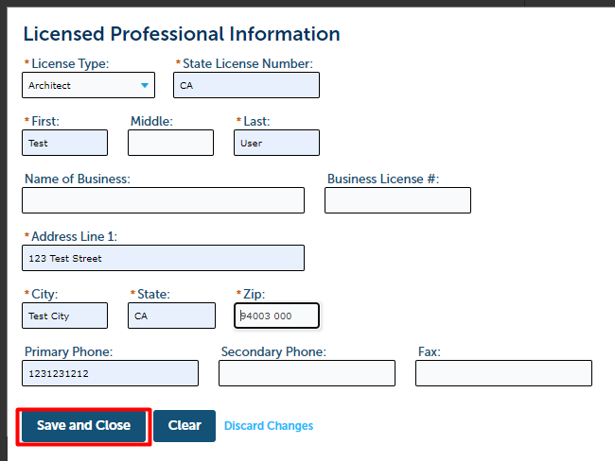
 | If you wish to add existing person as well (or instead), click ‘Search’ under ‘Licensed Contractor and Professional List’. |  | 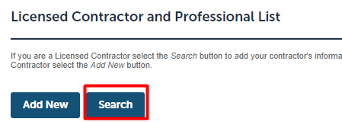
 | System opens ‘Look Up License’ pop up window. Enter search parameters and click ‘Look Up’. |  | 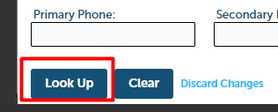
 | System displays search results. Select required person and click ‘Continue’. |  | 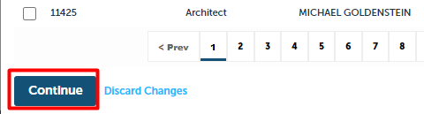
 | System displays list of all added Licensed Professionals. You may click ‘Edit’ to update the information or ‘Delete’ to remove person from the list. Once list is complete, click ‘Continue Application’. |  | 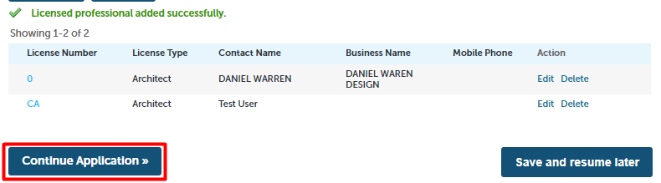
 | System opens ‘Project Information’ – ‘Work Description’ section. Fill out the form and click ‘Continue Application’. |  | 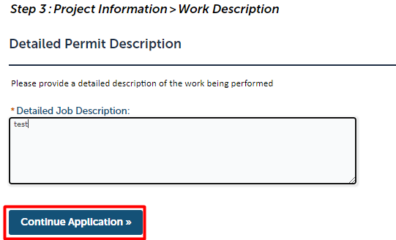
 | System opens ‘Project Information’ section. Fill out the form and click ‘Continue Application’. |  | 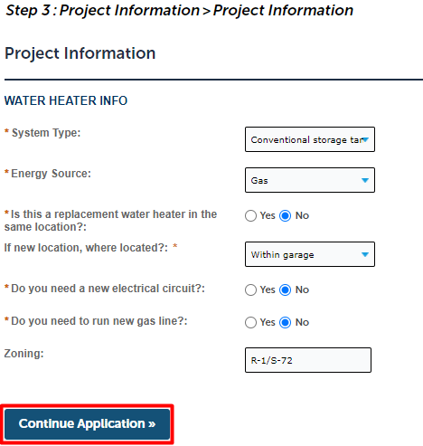
 | System opens ‘Attachments’ tab. Click ‘Add’ at the bottom of the page.
 | System opens ‘File Upload’ pop up window. Click ‘Add’ for the file selection.
 | System opens Windows Explorer with files on your machine. Select one or more files. | 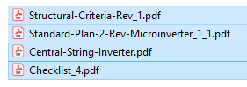
 | System displays list of selected files. Click ‘Continue’. | 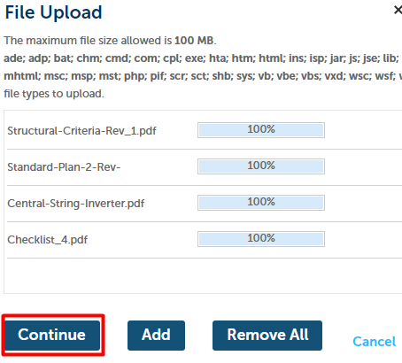
 | System displays preview of the files to be uploaded. Fill out the required ‘Description’ fields and click ‘Save’. | 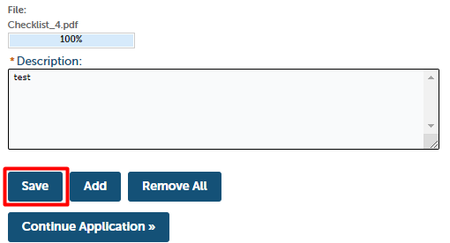
 | System displays list of the uploaded files.  You may view details or delete the uploaded file via Actions à View Details/Delete next to each row.  Click ‘Continue Application’. | 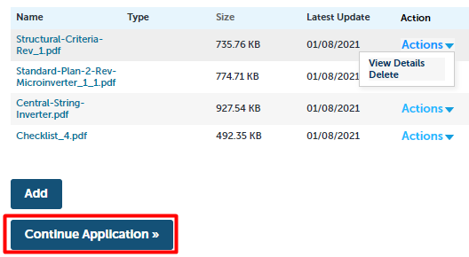
 | System opens ‘Review’ tab. Please review the summary of the entered information and the certification.  Check the checkbox and click ‘Continue Application’. |  | 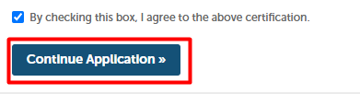
 | System opens ‘Pay Fees’ tab with list of preliminary fees to be paid. Click ‘Continue Application’. |  | 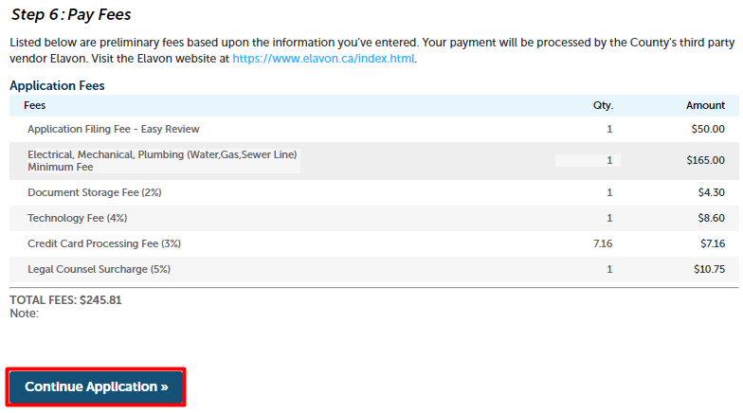
System opens ‘Payment Options’ page. Enter required payment information and click ‘Submit Payment’.
Once payment is processed, Application is submitted.
 | System displays ‘Record Issuance, providing your record number. You may print the receipt by clicking ‘Print/View Receipt’ and view the application information by clicking ‘View Record Details’.  You should also receive emails, notifying you about the successful payment and submitted application. |  | 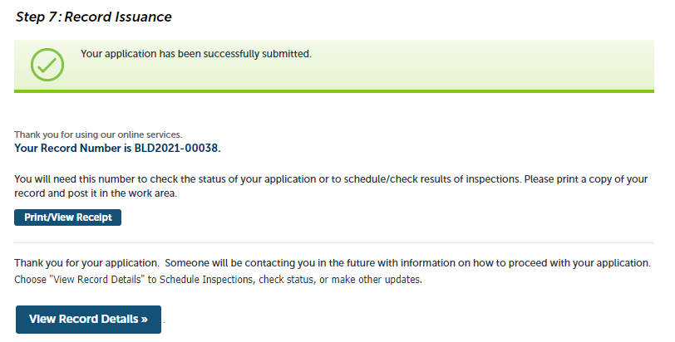

ACA How to create a Collection

Description
  - Portal allows group records in different collections for easier navigation and more simple way of finding records you may need more frequently.

Steps
 | On Portal, open any record page and click ‘Add Collection’ on the top-right of the page. | 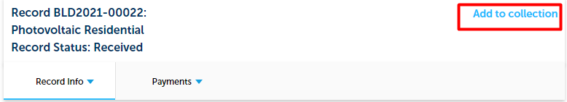
 | System will display ‘Add to collection’ pop-up window. Fill out the form and click ‘Add’. You must select from Existing Collection or create New Collection by providing the name. You may also provide a description. | 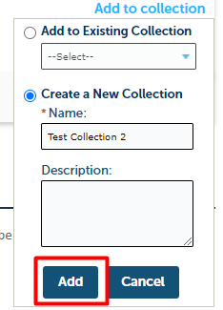
 | Once added, you may view your collections by clicking ‘Collections’ on the top of the page. This section allows to view, manage, delete the collection. | 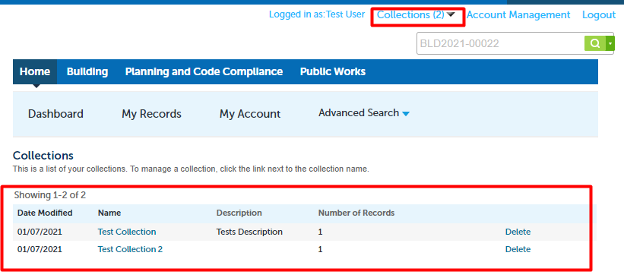

ACA How to locate status updates and inspection results

Description
Status updates and inspection results can be viewed on Portal via record details page.

Steps
 | To view status updates, on Portal, go to ‘My Records’ and click on the record number hyperlink for the record that you wish to check the statuses for. | 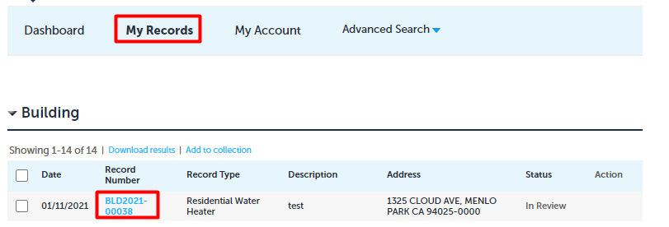
 | System opens record details page. Go to ‘Record Info’ à ‘Processing Status’. | 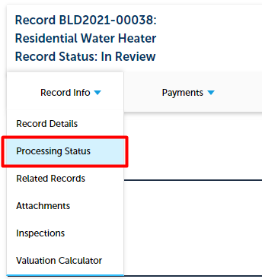
 | System opens ‘Processing Status’ page with progress information related to your application. You may click icon to expand the row and review additional details. | 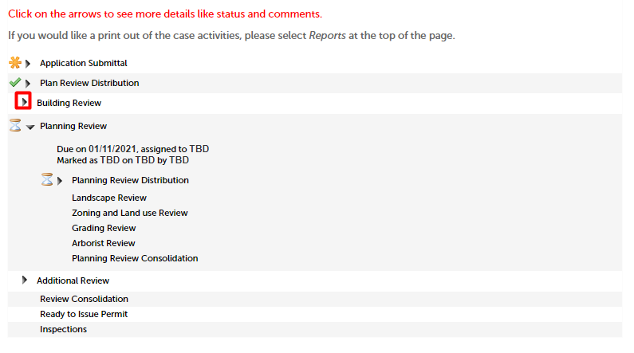
 | To review inspection information, go to ‘Record Info’ à ‘Inspections’. | 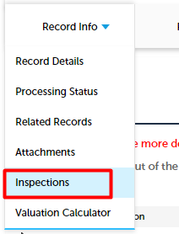
 | System displays all the upcoming and completed inspections related to your record. Click ‘View Details’ to review additional information of the specific inspection. | 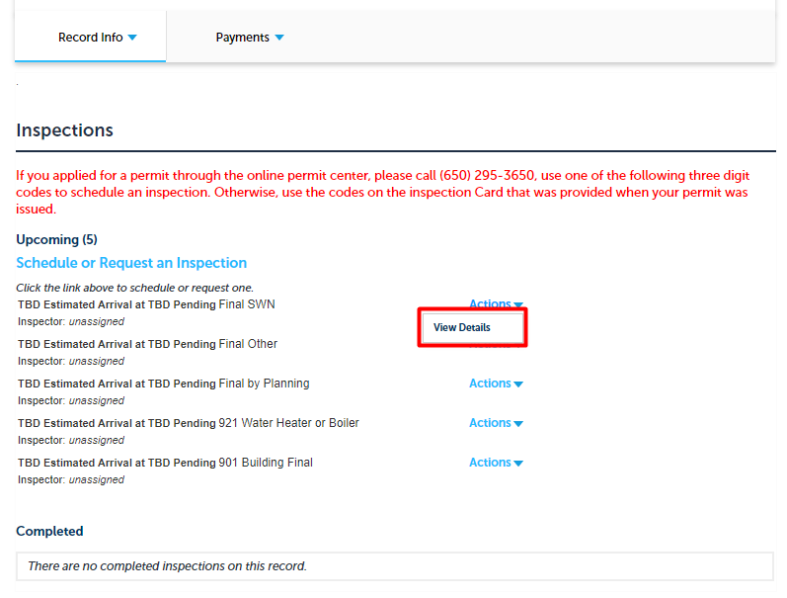
 | System opens pop up with additional information regarding the selected inspection. You may click ‘Print’ to print the displayed details. | 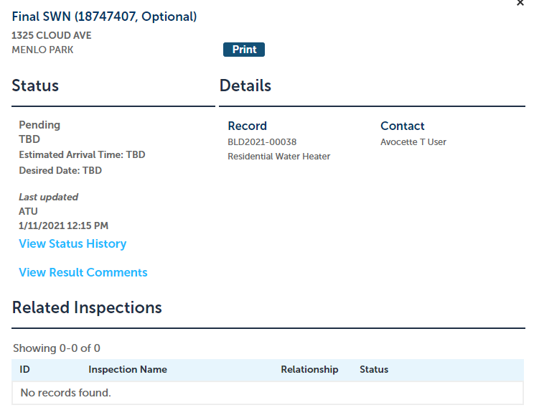

ACA When to expect email notifications

Description
Once you submit a permit application, you will be receiving emails with information such as fee payment confirmation, submitted application number, and the issues permit. Below are the examples of such emails.

Email Examples

 | ‘Order Confirmation’ email, confirming the processed fee for the application. | 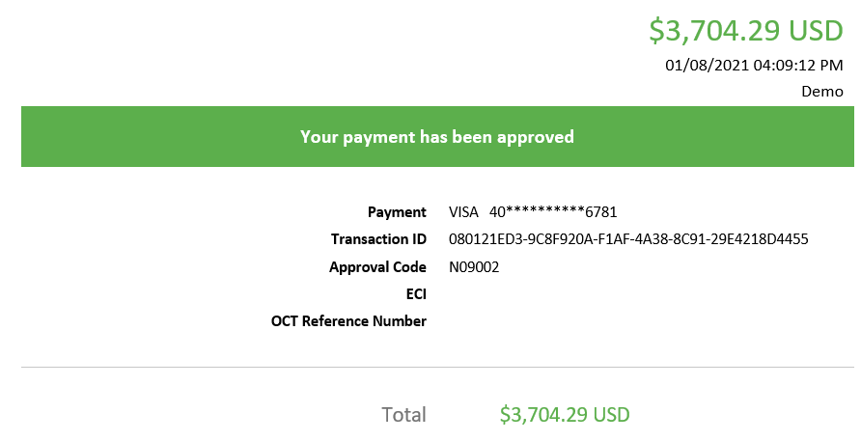
 | ‘Building Permit Application Submitted’ email, notifying about the accepted submitted application. | 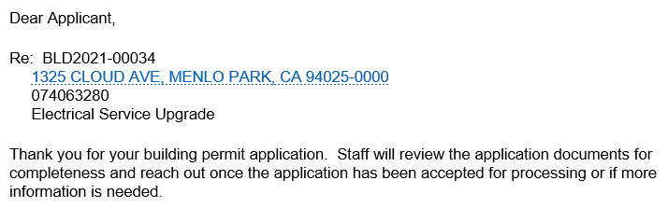
 | You may also receive email such as ‘Building Permit Issued’, providing notification about the issued permit the permit in PDF format attached to the email. | 