Cover Sheet
Date:
Applicant: |  |  | Phone:
Address: |  |  | Fax:
 |  |  | Email:
 |  |  | Web:
Project  Contact: |  |  | Title:
Amount Being Requested: $_________________ (maximum amount $5,000)

Minimum Qualifications Required to Submit Proposal:
Are you legally authorized to do business in the State of California?
Are you a not for profit or tax-exempt organization?
Are you a governmental agency?
Are you a school district or educational institution?
Are you located in San Mateo County and/or serve San Mateo County residents?
Have you actively and normally been engaged in community outreach and/or service provision for the past 3 years?

Application Form
Qualifications
Concise summary that describes the agency’s history, mission, programs, and services it provides. Please include length of time in business, and experience with conducting program outreach.
Region(s) Served | Populations Served
Please specify the regions within San Mateo County that your organization will conduct program outreach in. (see Region Map below) | Please provide a brief description of the communities that your organization reaches.
Region 1: Daly City, South San Francisco, San
Bruno, Broadmoor, Colma
Region 2: Millbrae, Burlingame, San Mateo, Foster
City, Belmont
Region 3: Redwood City, North Fair Oaks
Region 4: East Palo Alto, Menlo Park, Belle
Haven
Region 5: Half Moon Bay, Pescadero, Loma Mar
Region 6: Pacifica, El Granada, Montara

Staffing
Describe proposed staff and their roles/responsibilities. Identify the person who will be overseeing the County account. Provide the level of education, background, and experience that this person has.
Outreach Plan
Detail the planned approach and strategy for conducting an effective outreach campaign for the California Microbusiness COVID-19 Relief Grant Program. Include examples of specific outreach activities where possible.
Region Map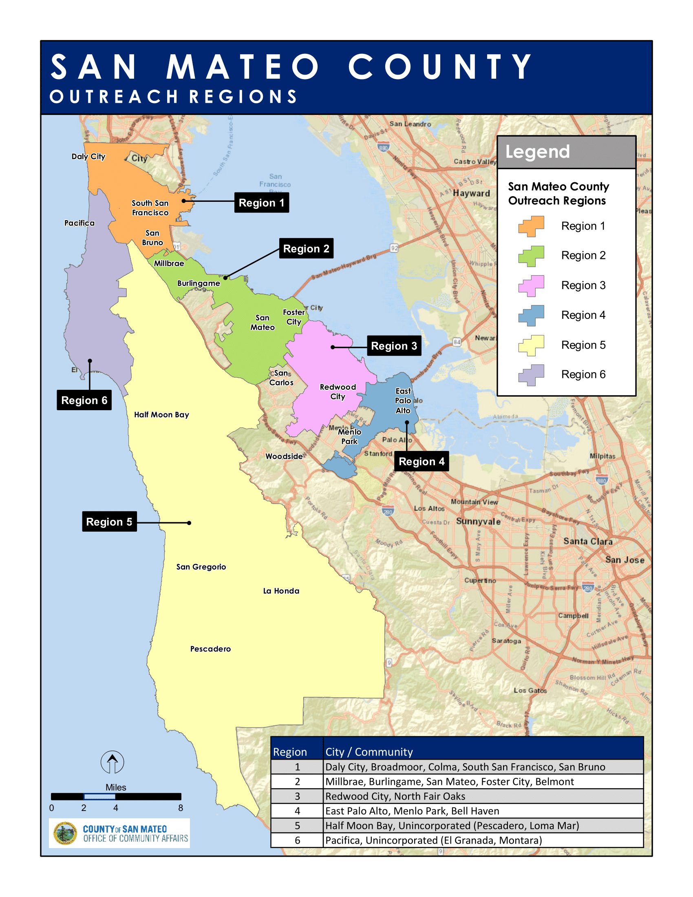
Cost Quotation/Budget Template

Expense | Description of Expense | Estimated Cost
PERSONNEL
Director wages
Administrative staff wages
PROFESSIONAL FEES
Professional fees
PROGRAM AND OPERATING
Supplies
Media/Advertising
Postage and shipping
Printing and publications
Other expenses not covered above (itemize)
Total Expenses | $0

