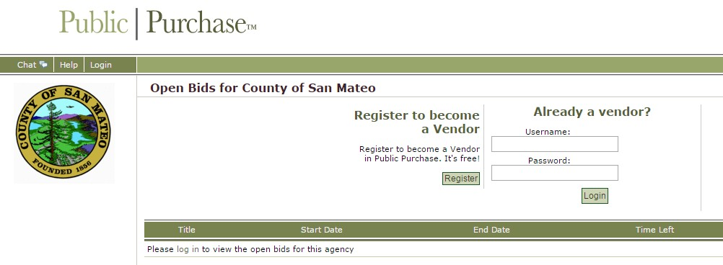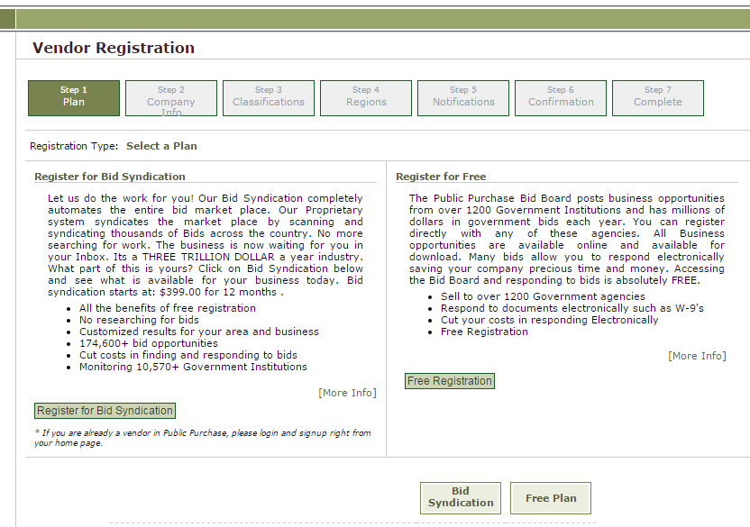

STEPS TO APPLY FOR OPEN GRANTS ON PUBLIC PURCHASE

1.

Register to become a Vendor this will allow you to see all open bids available in County of San Mateo.

2.

Register for free access to Public Purchase.

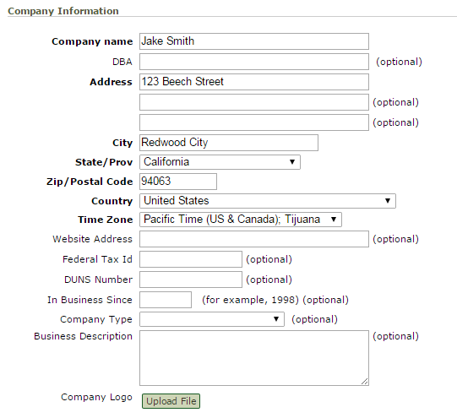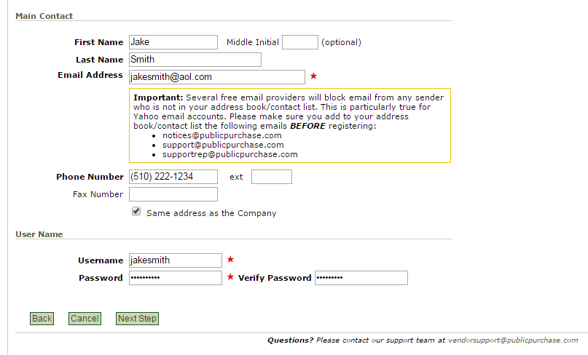3.

Fill out your work address if you have one. You may also fill out a personal address.

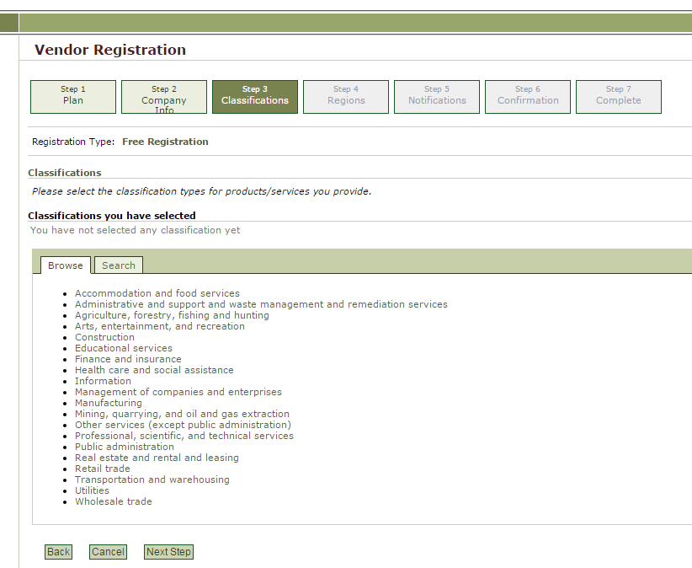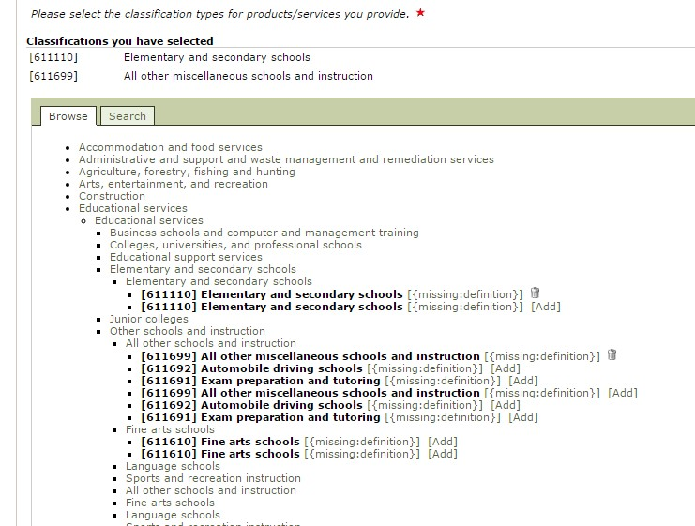4.

Select Educational Services and other service categories that you provide.

Example of selected classifications regarding types of services your organization is able to deliver.

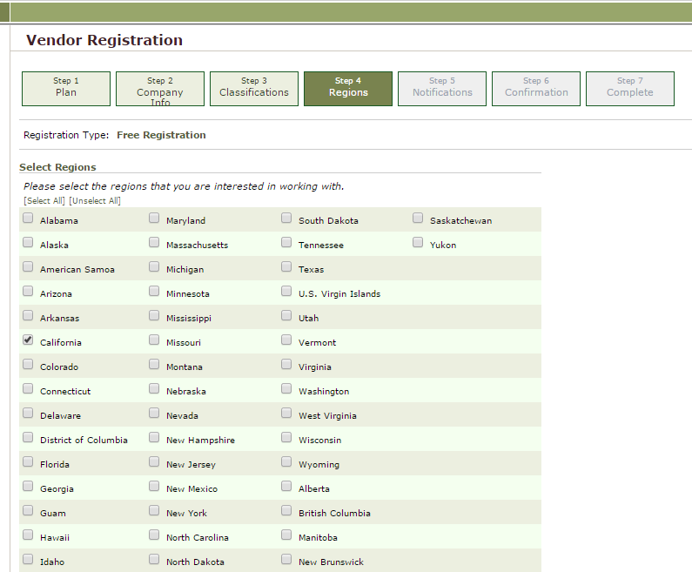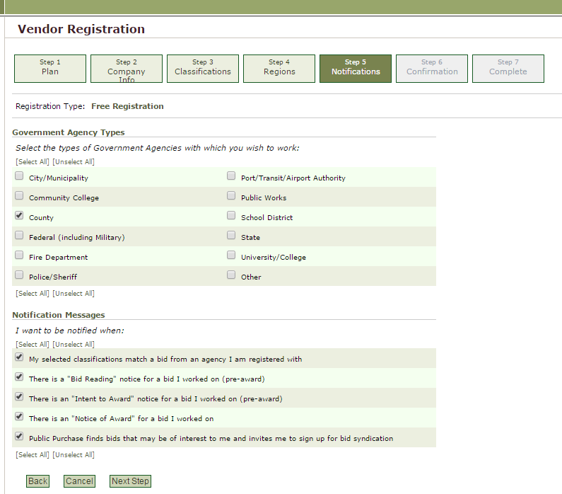5.

Select California

6.

Select County and keep notification messages checked. You may decide whether you wish Public Purchase to notify you of other bids of interest.

?

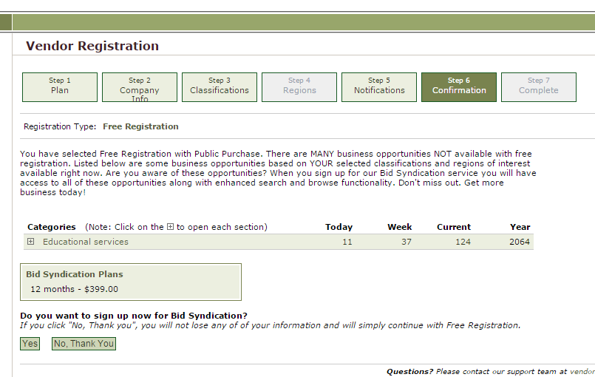7.

There is no obligation to sign up for a bid syndication plan.

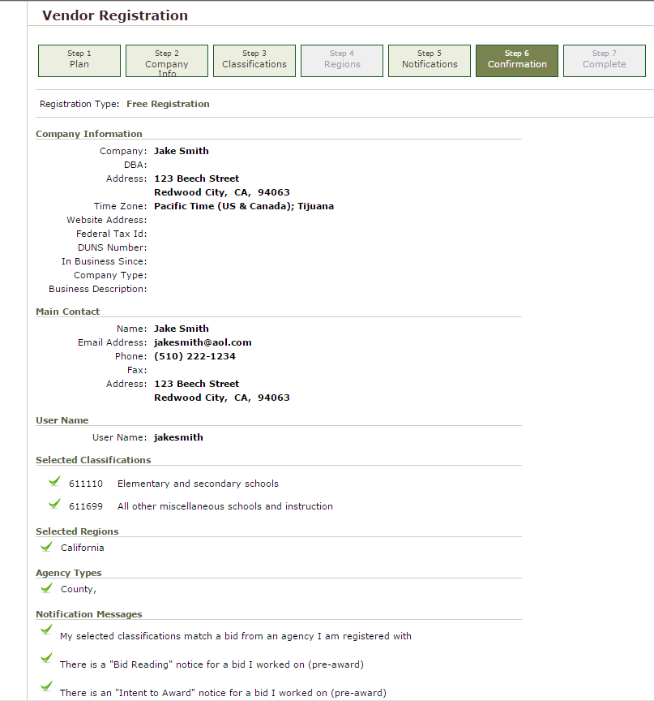8.

Review your information

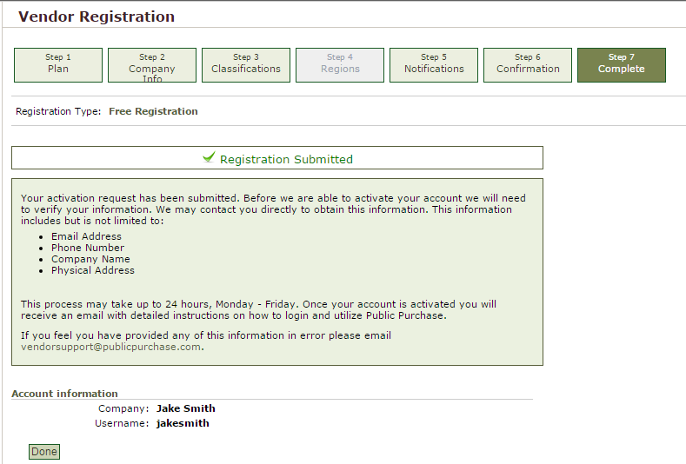9.

Congratulations! You have registered as a vendor in Public Purchase. You will be able to access grant information after you have been notified by email by Public Purchase.

