APPENDIX “A”
PROPERTY TO BE SEARCHED
This warrant is directed to Google LLC, headquartered at 1600 Amphitheater Parkway, Mountain View, California, (receiving search warrants via Google LLC’s secure web portal known as the law enforcement request system {LERS}) and applies to (1) GPS, WiFi or Bluetooth sourced location history data generated from devices that reported a location within the geographical region bounded by the following latitudinal and longitudinal coordinates, dates and times and (2) identifying information for Google Accounts associated with the responsive location history data:
Date: February 22, 2018
Time Period: 0820 hours (PST) through 0856 hours (PST)
Target Location:
Geographical box within the following four latitude and longitude coordinates of 2059 S Delaware St, San Mateo, California 94403:
37.550276, -122.305549 (northwest corner of defined area)
37.549074, -122.305393 (southwest corner of defined area)
37.549181, -122.304227 (southeast corner of defined area)
37.550317, -122.304212 (northeast corner of defined area)
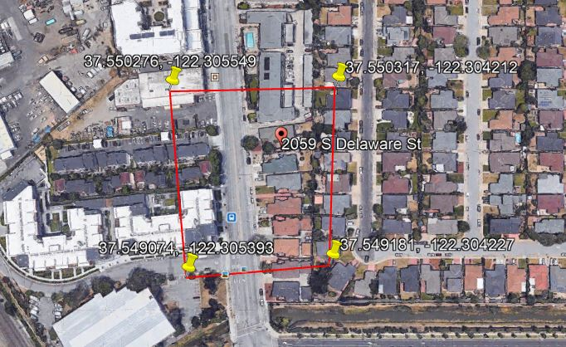

APPENDIX “B”
ITEMS TO BE SEIZED AND SEARCHED
Google shall provide responsive data (as described in Appendix “A”) pursuant to the following process:
To the extent within Google’s possession, custody or control, Google is directed to produce the following information associated with the Subject Accounts, which will be reviewed by law enforcement personnel to locate any evidence, fruits and instrumentalites of the crime under investigation:

- Location information: All location data, whether derived from Global Positioning System (GPS) data, cell site/cell tower triangulation/trilateration, and precision measurement information such as timing advance or per call measurement data, and Wi-Fi location, including GPS coordiantes, estimated radius and the dates and times of all location recordings between the following date and time at the location specified:

Date/Time: February 22, 2018 0820 hours (PST) through 0856 hours (PST).

Geocraphical box within the following four latitude and longitude cooridnates of 2059 S Delaware St San Mateo, California 94403

37.550276, -122.305549 (northwest corner of defined area)
37.549074, -122.305393 (southwest corner of defined area)
37.549181, -122.304227 (southeast corner of defined area)
37.550317, -122.304212 (northeast corner of defined area)

- Each device corresponding to the location data to be provided by Google will be identified only by a numerial identifier, without any further content or information identifying the user of a particular device. Law enforcement will analyze this initial data to identify users who may have witnessed or were involved in the crime

- For those accounts identified as relevant to the ongoing investigation through an analysis of provided records, and upon demand, Google shall provide additional location history outside of the predefined area for those relevant accounts to
APPENDIX “B” Cont…

determine path of travel. This additional location history shall not exceed 45 minutes plus or minus the first and last timestamp associated with the account in the initial dataset. The purpose of path of travel/contextual location points is to eliminate outlier points where, from the surrounding data it becomes clear the reported point(s) are not indicative of the device actually being within the scope of the warrant.

- For those accounts identified as relevant to the ongoing investigation through an analysis of provided records, and upon demand of the investigative agents, Google shall provide the subscriber’s information for those relevant accounts to include subscriber’s name, email address, IMEI and phone numbers, services subscribed to, recovery SMS phone number and recovery email address.

