APPENDIX “A”
PROPERTY TO BE SEARCHED
This warrant is directed to Google LLC, headquartered at 1600 Amphitheater Parkway, Mountain View, California, (receiving search warrants via Google LLC’s secure web portal known as the law enforcement request system {LERS}) and applies to (1) GPS, WiFi or Bluetooth sourced location history data generated from devices that reported a location within the geographical regions bounded by the following latitudinal and longitudinal coordinates, dates and times and (2) identifying information for Google Accounts associated with the responsive location history data:
Target Location #1
Date: August, 14, 2018
Time Period: 1745 hours (PST) through 1800 hours (PST)
Target Location:
Geographical box within the following four latitude and longitude coordinates of the 1800 block of S Grant St, San Mateo, California 94403:
37.552967, -122.302575 (southwest corner of defined area)
37.552933, -122.301907 (southeast corner of defined area)
37.554301, -122.302587 (northwest corner of defined area)
37.554298, -122.301922 (northeast corner of defined area)
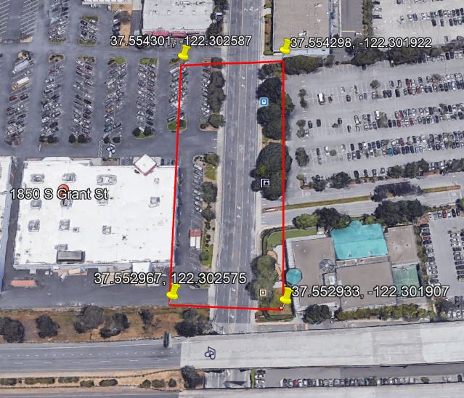
APPENDIX “A” Cont…
PROPERTY TO BE SEARCHED
Target Location #2
Date: August, 14, 2018

Time Period: 1805 hours (PST) through 1835 hours (PST)

Target Location:

Geographical box within the following four latitude and longitude coordinates of State Route 92 between Highway 35 to the west and Highway 35 to the east in San Mateo County, California 94062:

37.490132, -122.362918 (southwest corner of defined area)
37.510387, -122.346490 (southeast corner of defined area)
37.500204, -122.371132 (northwest corner of defined area)
37.513851, -122.350088 (northeast corner of defined area)

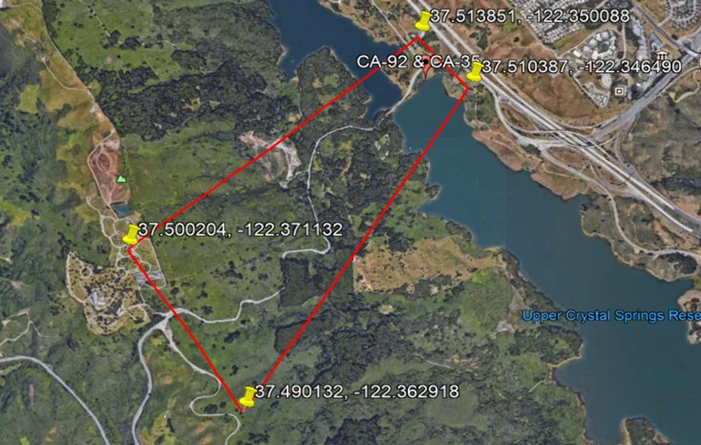

APPENDIX “A” Cont…
PROPERTY TO BE SEARCHED
Target Location #3

Date: August, 14, 2018

Time Period: 1858 hours (PST) through 1905 hours (PST)

Target Location:

Geographical polygon within the following five latitude and longitude coordinates of 1400 Fashion Island Blvd, San Mateo, California 94403:

37.557605, -122.287238 (northeast corner of defined area)
37.556833, -122.288408 (northern mid corner of defined area)
37.555806, -122.289122 (northwest corner of defined area)
37.555402, -122.288477 (southwest corner of defined area)
37.556556, -122.285882 (southeast corner of defined area)

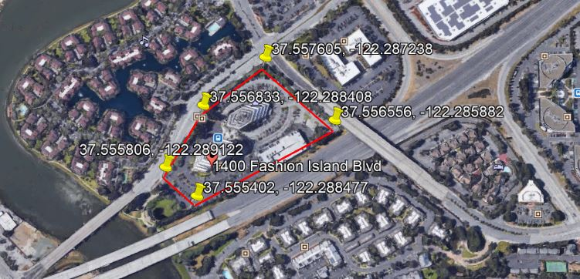

APPENDIX “B”
ITEMS TO BE SEIZED AND SEARCHED
Google shall provide responsive data (as described in Appendix “A”) pursuant to the following process:
To the extent within Google’s possession, custody or control, Google is directed to produce the following information associated with the Subject Accounts, which will be reviewed by law enforcement personnel to locate any evidence, fruits and instrumentalities of the crime under investigation:

- Location information: All location data, whether derived from Global Positioning System (GPS) data, cell site/cell tower triangulation/trilateration, and precision measurement information such as timing advance or per call measurement data, and Wi-Fi location, including GPS coordinates, estimated radius and the dates and times of all location recordings between the following date and time at the locations specified:

Target Location #1
Date/Time: August 14, 2018 1745 hours (PST) through 1800 hours (PST).

Geographical box within the following four latitude and longitude coordinates of the 1800 block of S Grant St, San Mateo, California 94403:

37.552967, -122.302575 (southwest corner of defined area)
37.552933, -122.301907 (southeast corner of defined area)
37.554301, -122.302587 (northwest corner of defined area)
37.554298, -122.301922 (northeast corner of defined area)

Target Location #2
Date/Time: August 14, 2018 1805 hours (PST) through 1835 hours (PST).

Geographical box within the following four latitude and longitude coordinates of State Route 92 between Highway 35 to the west and Highway 35 to the east in San Mateo County, California 94062:

37.490132, -122.362918 (southwest corner of defined area)
37.510387, -122.346490 (southeast corner of defined area)
37.500204, -122.371132 (northwest corner of defined area)
37.513851, -122.350088 (northeast corner of defined area)

APPENDIX “B” Cont…

ITEMS TO BE SEIZED AND SEARCHED

Target Location #3
Date/Time: August 14, 2018 1858 hours (PST) through 1905 hours (PST).

Geographical polygon within the following five latitude and longitude coordinates of 1400 Fashion Island Blvd, San Mateo, California 94403:

37.557605, -122.287238 (northeast corner of defined area)
37.556833, -122.288408 (northern mid corner of defined area)
37.555806, -122.289122 (northwest corner of defined area)
37.555402, -122.288477 (southwest corner of defined area)
37.556556, -122.285882 (southeast corner of defined area)

- Each device corresponding to the location data to be provided by Google will be identified only by a numerical identifier, without any further content or information identifying the user of a particular device. Law enforcement will analyze this initial data to identify users who may have witnessed or were involved in the crime

- For those accounts identified as relevant to the ongoing investigation through an analysis of provided records, and upon demand, Google shall provide additional location history outside of the predefined area for those relevant accounts to
determine path of travel. This additional location history shall not exceed 45 minutes plus or minus the first and last timestamp associated with the account in the initial dataset. The purpose of path of travel/contextual location points is to eliminate outlier points where, from the surrounding data it becomes clear the reported point(s) are not indicative of the device actually being within the scope of the warrant.

- For those accounts identified as relevant to the ongoing investigation through an analysis of provided records, and upon demand of the investigative agents, Google shall provide the subscriber’s information for those relevant accounts to include subscriber’s name, email address, IMEI and phone numbers, services subscribed to, recovery SMS phone number and recovery email address.

