REQUEST FOR PROPOSALS
Title: COVID-19 Outreach
The County of San Mateo is seeking proposals from community organizations to assist in outreach and education to residents to educate residents on how to help stop the spread of COVID-19
Solicitation Number | COVID-19 Outreach RFP #OCA1001
Number of contracts expected to be awarded | Multiple
Funding Sources | ☐Federal ☐State ☒County ☐Other
Expected Contract Duration | 6 months
Options to Renew | NA
Proposal Submission | Email to: CMO_COVID_RFP1@smcgov.org
Authorized Contact Person | Emma Gonzalez
Authorized Contact Person E-mail | elgonzalez@smcgov.org
E-mail Address for Protests | protests@smcgov.com
RFP Released | September 1, 2020 4:00 PM PST
Deadline for Questions, Comments and Exceptions | September 12, 2020 5:00 PM PST
Proposal Due Date and Time | September 17, 2020 5:00 PM PST
Anticipated Contract Award Date | October 2020

Introduction
The San Mateo County Office of Community Affairs wants to ensure that the community has ready access to important and updated information during the COVID-19 pandemic.

San Mateo County Health, working in tandem with other County agencies, is actively responding to the COVID-19 pandemic to protect the public and keep the community informed. The time to act is now to protect vulnerable populations and the community at large and the County seeks partners to assist in this effort to keep our neighbors informed regarding COVID-19.

Eligible Applicants
- Organizations: Must be a tax-exempt organization, such as organizations that are tax exempt under Sections 501(c)3, 501(c)4, or 501(c)6 of the Internal Revenue Code (IRC), or an organization that files a Form 990, Form 990 EZ, or Form 990-N with the Internal Revenue Service (IRS), and that serves San Mateo County residents.
- School Groups/Districts: Must provide educational services to residents and students in San Mateo County
- Government Agencies: San Mateo County cities, San Mateo County districts/agencies, and libraries in San Mateo County
- Coalitions: Groups comprised of two or more qualifying organizations, school groups, student associations, or government agencies.

Proposer Requirements
- Proposers will use funds paid pursuant to any contracts awarded pursuant to this RFP only for COVID-19 outreach/educational activities.
- Proposers who are awarded contracts will be required to submit reports on COVID-19 activities to the County as requested.
- Agree to communicate with the County as soon as possible should any challenges be identified that will impact the organization’s ability to meet target outcomes within the by the end of the contract date, April 2021.
- All applicants selected pursuant to this RFP will be required to enter into a contract with the County containing the terms set forth in the County’s Short Form contract.
- Services provided by the Contractor pursuant to the Agreement will be performed in compliance with all applicable orders of the San Mateo County Health Officer and other state, local, or federal authorities related to COVID-19.

COVID-19 Contracts
COVID-19 RFP #OCA1001: COVID-19 Outreach
Description | Educate, and outreach to targeted vulnerable populations in San Mateo County to stop the spread of COVID-19.  Contractor will be expected to perform activities, such as:  - Share easy-to-implement public health tips with San Mateo County residents  - Encourage mask wearing, physical distancing, handwashing, sanitizing and discourage large gatherings  - Share precaution health tips that can be applied while following health guidelines  - Direct individuals and small businesses facing economic hardship to smcgov.org and cmo.smcgov.org/covid-19-resources for additional resources and information about assistance programs  - Direct individuals and small businesses to register for e-Community Newsletter (English/Spanish)  - Distribute outreach material and resources, including face coverings and hand sanitizers to the public  - Virtual Based outreach- provide guidance on safety health tips  - Create COVID-19 specific content for various social media channels  - Create COVID-19 messaging and deliver utilizing phone bank (if applicable)  - Host a pop-up COVID testing site and outreach to local residents/businesses (on a limited basis and must be mutually agreed upon with County in advance)  - Convene volunteers to assist with pop-up COVID testing site (if applicable)
Priorities | San Mateo County will prioritize funding for organizations that can reach the following populations, which are currently underserved in the regional outreach ecosystem:  - Latinx community  - Farmworkers  - Pacific Islander community  - Black/African American community  - Immigrant communities  - LGBTQ+ community  - People experiencing homelessness  - People with disabilities  - Seniors  - Youth
Requirements | - If needed, assist in translation of outreach and promotional material  - Submit reports and invoices as directed in contract
County Provides | - Masks  - Face shields  - Hand sanitizers (limited supplies)  - Banners
Funding Level | Up to $20,000

Timeline:
September 1, 2020 4:00pm RFP Released
September 12, 2020 5:00pm Deadline for questions submitted to County
September 17, 2020 5:00pm RFP Deadline

Contract awards will be made following consideration of all timely and complete proposals by a review panel. The Office of Community Affairs requires all contractors to submit reports as outlined in the contract. Failure to submit a report, incomplete reports, and/or late reports may jeopardize future grant funding.

Proposal Questions

1. Proposal – please provide no more than two pages for this section.
1A. Project Description - description of your proposed plan for your COVID-19 outreach, including your approach and strategies for implementation. Indicate how your proposal will achieve the overall objectives and outcomes outlined in the RFP.

1B. Hard-to-Reach/Vulnerable Populations – description of the target Hard-to-Reach/vulnerable populations that will be served through the proposed efforts, including estimated number of people to be reached. Describe the community that your organization will work with. Proposers are encouraged to be specific.

1C. Experience – Include any experience and number of years of experience your organization has in conducting outreach and/or working with the target community identified in your RFP response. Provide an example that best highlights your success.

1D. Outreach Plan – description of proposed activities, timeline, and intended outcomes to meet the objectives and milestones in the scope of work outlined in the RFP. Please detail any areas in which you will be leveraging existing programs and activities.

1E. Milestone and Deliverables – Indicate your ability to meet the milestones and deliverables outlined in the RFP for your contract category. If you foresee any challenges, explain them and propose a revised timeline.

2. Exceptions – Please list any exceptions to the final solicitation and to the County’s standard form of contract, if any.

3. Current Work Environment- Will you be working primarily from home, an office, or doing
in-person outreach?

4. Financial Statements – Will be required at time of proposal award.

COVID-19 OUTREACH
FUNDING APPLICATION
PROPOSAL COVER SHEET

Date:
Applicant: |  |  | Phone:
Address: |  |  | Fax:
 |  |  | Email:
 |  |  | Web:
Project  Contact: |  |  | Title:
Amount Being Requested: $_________________ (maximum amount $20,000)

Minimum Qualifications Required to Submit Proposal:

Are you legally authorized to do business in the State of California?

Are you a not for profit or tax-exempt organization? Provide documentation to this verify status.

Are you a governmental agency?

Are you a school district or educational institution?

Are you located in San Mateo County and/or serve San Mateo County residents?

Have you actively and normally been engaged in community outreach and/or service provision for the past 3 years?

APPLICATION FORM

Date:
Applicant: |  |  | Phone:
Address: |  |  | Email:
 |  |  | Web:
Project  Contact: |  |  | Title:

Fed EIN: |  | IRS Code: |  | Year  Incorporated: |  | Date of Last  Annual Audit:
Annual Operating Budget: $ |  | Total Project  Budget: $ |  | Amount Being Requested: $

REGIONS TO BE COVERED (Check all that apply) | POPULATIONS TARGETED (Check all that apply)  Applicants should indicate which regions of the County they will be conducting outreach in.
Daly City, SSF, San Bruno, Broadmoor, Colma + Unincorp.  Millbrae, Burlingame, San Mateo, Foster City, Belmont + Unincorp.  Redwood City, North Fair Oaks  East Palo Alto, Menlo Park, Belle Haven  Half Moon Bay + Unincorp. (Pescardero, Loma Mar)  Pacifica + Unincorp. (El Granada, Montara)  *See map | African American  Asian/Pacific Islander  Children (0-5)  Disabled  Hispanic/Latinx  Homeless  Immigrants/ Refugees  LGBTQ+  Limited English Proficient Limited/No Internet Access | Low Income  Native American  Public Benefits Recipients  Public Housing Residents  Renters  SRO Residents  Seniors (65+)  Veterans  Young Adults (17-25)  Other_________________
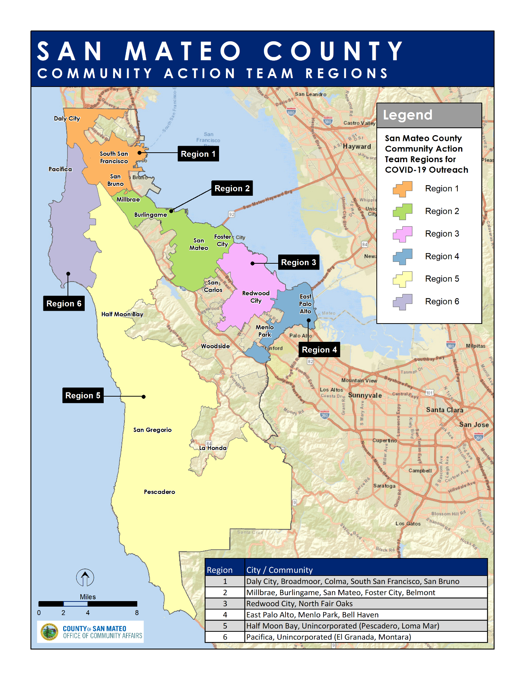

Budget Template
Expenses | Proposed Use of SMC Funds | Description of Expenses
PERSONNEL
Director wages
Administrative staff wages
PROFESSIONAL FEES
Professional fees
PROGRAM AND OPERATING
Supplies
Media/Advertising
Postage and shipping
Printing and publications
Other expenses not covered above (itemize)
Total Expenses | $0

Any Questions?
If you have any questions about the contract program, guidelines, or application please communityaffairs@smcgov.org

Email Completed Application to: CMO_COVID_RFP1@smcgov.org

