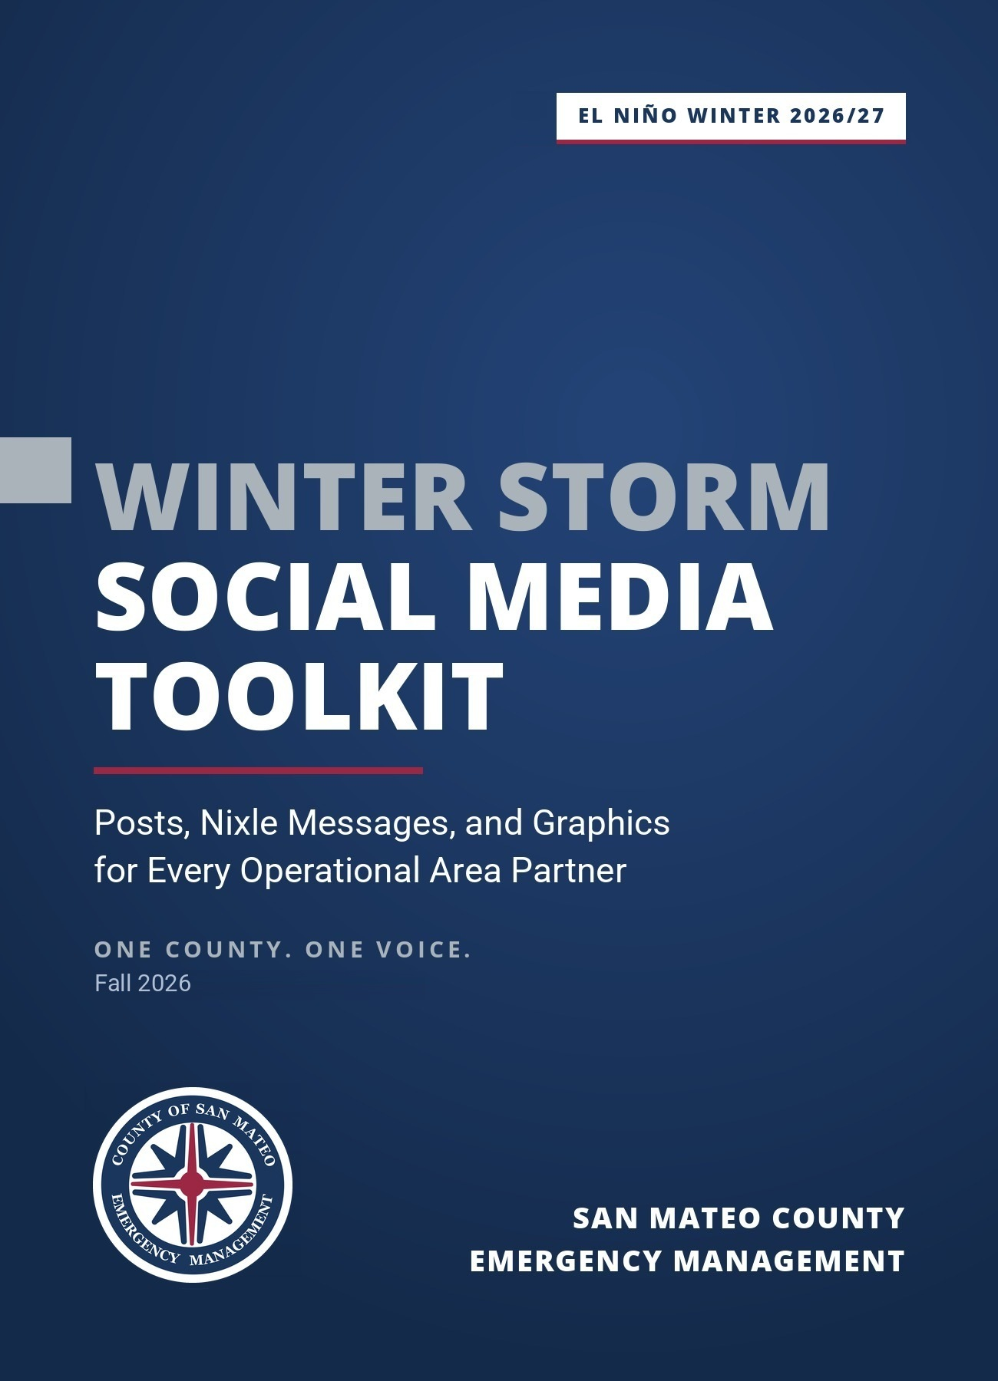

Contents
About This Toolkit How to use it and the Five Elements
One County, One Voice The core message; locked, flexible, and ask first; holding statements
Who Posts What Best fit posts and channels for each type of partner
Why This Approach Works The research behind the messages

El Niño Key Facts What's known, what's forecast, and how to say it
Messaging Guardrails Do and don't, plus plain language terms
Before You Post Fill in values, links, accessibility, and the posting checklist
Posting Calendar Week by week timing for social and Nixle
Phases 1 to 4 24 message sets with posts, graphics, alt text, and Five Elements checks
Nixle Message types, SmartPath delivery, rules, and templates N1 to N7

FEMA and Ready.gov Resources Federal graphics and messages to pair with this kit, and what to skip
Beyond Social Media Newsletter, signs, radio and video, and an outreach script
Handoff to the Alert and Warning Messaging Library When to stop preparedness posting
Stay Connected Op Area calls, updates, and monthly report back
Graphics Index File names for every graphic and flyer
Sources Research, data, and resource links

About This Toolkit
This toolkit aims to give every partner in the San Mateo County Operational Area the same phrasing, facts, and graphics for the 2026-27 winter storm season. It's written for cities and towns, law and fire agencies, public works and flood control, water and special districts, County departments, schools, libraries, community based organizations, faith communities, chambers, and elected offices. If you talk to the public in San Mateo County, it's for you.
Forecasters expect a very strong El Niño this winter, and public attention is high. That attention is an opening. Every post uses El Niño as the reason to act now and points people to the same 4 steps, the same sign up link, and the same county web page. When 38 jurisdictions and hundreds of partners say the same thing in their own voice, residents hear one county.

What's inside. Drafts for 8 channels: short posts for X, Bluesky, and Threads; longer posts for Facebook, Instagram, Nextdoor, and LinkedIn; and 7 Nixle templates. There are 24 message sets in all, each with a matching graphic and alt text, plus ready copy for newsletters and websites, digital signs, radio and video, and in person outreach.
Why the words match our alerts. The language mirrors the San Mateo County Alert and Warning Messaging Library, and every message follows its Five Elements Framework: who's speaking, the hazard and its impacts, the location, the preparedness/readiness action, and the time. Warning research finds people are more likely to take protective action when a message includes all 5 (The Warning Lexicon, Natural Hazards Review). When preparedness posts and emergency alerts share that shape, residents learn to recognize our messages long before they need to act on one.
Why one voice matters. Trust is built in blue skies. When every partner shares messages that are clear, consistent, and complete, residents learn they can rely on what they hear from us. Then in grey and dark skies, when an alert or warning goes out, they listen and act instead of stopping to check another source.

How to Use It
Start with the One County, One Voice section so you know which parts to keep word for word. Pick the week's post from the Posting Calendar, then copy the short post for X, Bluesky, or Threads, or the long post for Facebook, Instagram, Nextdoor, or LinkedIn. Replace every bracketed placeholder such as [AGENCY] and [LOCATION]; placeholders appear in bold. Attach the matching graphic with its alt text, run the Posting Checklist, and publish. If you run a Nixle channel, send the matching Nixle template the same day so your subscribers see the same message.

Five Elements Framework
Every message in this kit carries 5 elements: the Agency that's speaking, the Hazard and its Impacts, the Location, the Protective Action people should take, and the Time when it matters. In preparedness posts the elements work a little differently than in an alert:

Element | In an emergency alert | In a preparedness post
Agency | "SMC Alert: [AGENCY]" | "[AGENCY]:" with no "SMC Alert:" prefix
Hazard and Impacts | What is happening now | What El Niño storms could do this winter
Location | The affected area | Your jurisdiction, plus a local condition: creeks, low streets, shoreline, steep slopes
Protective Action | What to do right now | The 1 step to take before storms arrive
Time | When impacts occur | A deadline: "before the first storm," "this month," a King Tide window

One County, One Voice
One voice doesn't mean one account posting for everyone. It means every partner, in their own voice and on their own channels, carries the same core message, the same facts, and the same actions, so a resident who follows their city, their fire district, and their kid's school hears one story 3 times instead of 3 stories once.

The Core Message
A very strong El Niño raises the odds of a wetter, harder winter. We know how to get ready for winter; this year, we start earlier. Make a plan, build a kit, know your sandbag site, and sign up for SMC Alert at smcalert.info.
Use this in interviews, council and board remarks, newsletters, and anywhere a post needs a 1-line summary. The tone is confident, not alarmed: the risk is real, the steps are simple, and people can do this.

Locked, Flexible, and Ask First
It’s important that all partners have room and flexibility to make this their own. Here's where that room is. Locked items keep residents from hearing 2 versions of a fact; everything flexible is yours to shape.
Locked: use as written | Flexible: make it yours | Ask SMC EM first
• NOAA wording: El Niño "raises the odds"; greater than 90% chance of a very strong event  • King Tide windows: Nov 24 to 26, Dec 22 to 25, Jan 20 to 23  • The 4 steps, in order: plan, kit, sandbags, SMC Alert  • smcalert.info and the county winter weather page  • #StormReadySMC on every post  • Safety figures: 6 and 12 inches of water; 20 feet for generators  • Flood water action: don't drive or walk into flood water  • "SMC Alert:" prefix stays reserved for real alerts | • Your opening sentence and agency voice  • Local streets, creeks, landmarks, and neighborhoods in [LOCATION]  • Your own local photos in place of or alongside the graphics  • Which posts you run and when, within the calendar  • Your local resources: sandbag site, public works line, Nixle keyword, community centers  • Trimming length for your platform  • Translation through your own qualified provider | • Anything about funding, reimbursement, or proclamations  • Forecast claims beyond NOAA, NWS, and SMC EM  • Evacuation zones, orders, or shelter locations  • Sandbag supply levels or new sites  • Statements about another agency's actions  • Media requests about countywide readiness

Hot Questions and Holding Statements
Residents and reporters are asking these right now. Use the line as written, then point to the county page. If the question goes further than the line, route it to SMC EM rather than answering on the spot.
If you hear | Say this
"Does the Governor's emergency mean the county is getting money?" | The Governor's September 21 proclamation directs state agencies to prepare, stage resources, and speed up permitting. It doesn't bring local funding or make any finding about San Mateo County. It matches the readiness work already underway here.
"Is this a super El Niño?" | NOAA gives a greater than 90% chance of a very strong El Niño this winter. That raises the odds of a wetter, harder winter. It doesn't tell us which storms, when, or where. Getting ready now pays off either way.
"Will it be like 1998 or January 2023?" | No one can say that yet, and past winters aren't a forecast. What we do know is when the King Tides arrive and what each household can do today.
"Where do I get sandbags?" | A list of City sites and hours is available and has been confirmed with each city per SMCEM outreach. SMCEM is building a comprehensive landing page to direct residents to but that is still in development. In the meantime, please share or repurpose the list through your current outreach channels and products. Please don't rely on locations from past years.
"How will I know if I need to leave?" | Sign up for SMC Alert at smcalert.info, look up your zone at protect.genasys.com, and follow your local agency. If you get Nixle updates from us, sign up for SMC Alert too; they're separate.
"What's the county doing?" | San Mateo County Emergency Management is tracking storms with UC San Diego's Scripps CW3E and the National Weather Service, coordinating with every city and response partner in the county, and aligning alerts and warnings across agencies.
"Should I buy flood insurance?" | We can't advise on individual policies. Most home and renters policies don't cover flooding, and new flood policies usually take 30 days to start. Talk to your agent or visit floodsmart.gov.
Questions about federal forecasting, staffing, or budgets | Route to SMC EM. Don't speculate.

Rumor Control
Storm seasons draw rumors, recycled photos, and increasingly AI generated flood images and videos. Don't share storm imagery you can't trace to a named source, and use your own photos of your own community whenever you can. When a rumor starts to spread, correct it by leading with the fact rather than repeating the rumor in your headline, and link to the source. If you see a rumor gaining traction, send the link to SMCEM so a correction can go out countywide instead of 20 slightly different ones.

Who Posts What
Every message set lists who's best placed to post it. This table is the quick version, so each partner can find the posts that fit its audience and channels. All partners should run 01, 02, 17, and 24.
Partner | Posts that fit best | Channels that reach your people
Cities and towns | 05, 06, 08, 12, 18, 20 | Social, city website, newsletters, Nextdoor agency posts, Nixle
Police and Sheriff | 12, 13, 14, 16 | Nixle, X, Facebook, Nextdoor
Fire agencies | 06, 15, 16, 19 | Instagram, Facebook, Nixle, station reader boards
Public works and flood control, including OneShoreline | 05, 06, 11, 16, 19 | Websites, Nextdoor, service request apps
Water, sanitary, and special districts | 06, 07, 11 | Bill inserts, customer email, websites
School districts, County Office of Education, child care | 21, 13, 14 | Parent notification systems, newsletters, Instagram
Libraries and community centers | 08, 09, 23 | Flyers, digital signs, program announcements
CBOs and faith communities | 09, 10, and the outreach script | Group texts, WhatsApp, bulletins, in person
Chambers and business groups | 20, 07, 23 | Member email, LinkedIn
Board of Supervisors and elected offices | 10, 11, 18 by district | Newsletters, social, town halls
Animal services and veterinary partners | 22 | Social, clinic signage
Transit and utilities | 12, 13, 15, 17 | Rider and customer alerts, social

Why This Approach Works
The messages in this kit apply research by Dr. Keri K. Stephens of The University of Texas at Austin and her colleagues, whose flood communication work was developed with the Texas Water Development Board. Her research is Texas based, so we adapted the principles, not the messages. All wording in this kit is original to San Mateo County and written for our hazards: coastal flooding, creek and street flooding, landslides, falling trees, and outages.
Her work also backs the structure we already use. The research she cites finds that effective warnings need a clear hazard, a specific location, an action, timing, and a credible source. Those are the Five Elements. Full citations are on the Sources page.

What the research found | How this toolkit applies it
People act on messages that feel personally relevant. A single message rarely moves every group. | Audience versions for young drivers (14), new residents (08), older adults and people with disabilities (09), Coastside residents (18), businesses (20), families (21), and pet owners (22). [LOCATION] names local conditions.
People need to know what to do and believe it will work, not just that a risk exists. | Every risk is paired with 1 specific action and what that action achieves.
People who've lived through a flood take the risk more seriously. Those who haven't often don't understand hazards like flash floods. | Posts reference the January 2023 storms many residents remember. Post 08 gives newer residents what experience would have taught.
A common reaction to warnings is some version of "It's never about flooding where I am." | Posts name specific conditions (creeks, low streets, shoreline, steep slopes) instead of the whole county.
Hearing about a threat from someone you know is one of the most effective ways to prompt action, and multiple warnings build urgency. | Long posts end with a share or check on a neighbor ask. Post 10 is built around it, and the Amplify First rule puts the same message in front of residents from several sources.
Messages that say what the community expects moved people more than messages about what most people do. | The drains post (06): 1 blocked drain can flood the whole block, and neighbors are counting on everyone.
Drivers who'd seen flood safety road signs before were more likely to turn back from a flooded road. Two thirds of respondents said they'd received few or no flood safety messages. | The same phrases, hashtag, and graphics run all season, and the flooded roads message repeats monthly.
Technical terms get misread. Many people read a "Low Water Crossing" sign as meaning the water is low and safe to cross. | A plain language terms table. "King Tides" is always paired with the hazard and an action.
Young adult drivers tend to feel invincible but care about their vehicles. | Post 14 leads with what flood water does to a car.
Opt in alert systems only work if people know they exist and keep their information current. Social media reaches only some residents. | SMC Alert posts ask people to update their information. Nixle templates, a printable flyer, newsletter copy, and an outreach script reach people who aren't on social media.

El Niño Key Facts
Verified September 23, 2026. NOAA updates its El Niño discussion on the second Thursday of each month (next: October 8) and its seasonal outlook on the third Thursday (next: October 15). SMC EM will send a toolkit update after each NOAA release. Check the sources before quoting numbers.

What's Known Now
NOAA's Climate Prediction Center has an El Niño Advisory in effect. El Niño conditions are present and strengthening. King Tide dates are set by the sun and moon, not the weather. The Coastal Commission's statewide dates are November 24 to 26 and December 23 to 25, 2026, and January 21 to 22, 2027, and it notes Northern California may also see King Tides on December 22, January 20, and January 23. San Mateo County plans around the full windows: Nov 24 to 26, Dec 22 to 25, and Jan 20 to 23. A storm arriving during one of those windows is the scenario the county is planning for now.
On September 21, Governor Newsom proclaimed a statewide State of Emergency for El Niño preparedness. It directs state agencies to prepare, stage resources, and speed up permitting. It brings no local funding and makes no finding or directive toward San Mateo County.

What's Forecast (Could Change)
NOAA gives a greater than 90% chance of a very strong El Niño this fall and winter, and a 75% chance the event will be stronger than any El Niño since 1950. NOAA notes that with an event this strong, El Niño type impacts are more likely but not guaranteed. NOAA's seasonal outlook favors above normal precipitation for much of coastal California from December through April, with the highest odds January through March, and expects El Niño's effects to build slowly in late fall and ramp up in mid to late winter.

What It Means for San Mateo County
Coastal and tidal flooding is the higher confidence risk. King Tide dates are known in advance, and El Niño tends to raise water levels along the coast. Rain flooding depends on individual storms and can't be predicted weeks ahead, so SMC Emergency Management will share storm specific information as forecasts firm up. A quiet December doesn't mean El Niño fizzled; keep posting through March.

Say It This Way
A very strong El Niño raises the odds of a stormy winter. It doesn't guarantee one. We know how to get ready for winter; this year, we start earlier. Getting ready costs little and pays off either way.

Messaging Guardrails
Do | Don't
Say El Niño "raises the odds." | Say storms "will" come, or predict rain totals or storm counts.
Keep coastal flooding and rain flooding separate. | Present past El Niño winters, like 1997-98, as a forecast.
Pair every risk with 1 clear action. | Post a risk without telling people what to do about it.
Name local conditions in [LOCATION]. | Rely only on countywide generalities.
Start preparedness posts with "[AGENCY]:". | Start preparedness posts with "SMC Alert:". That prefix belongs to real alerts in the Messaging Library.
Repeat the same phrases, hashtag, and graphics all season. | Invent a new slogan every week.
Name the action plainly: don't drive or walk into flood water. | Lean on a slogan in place of a clear action, or use other agencies' campaign slogans.
Hold sandbag posts until Public Works confirms sites and hours. | Post sandbag locations from memory or past years.
Describe the Governor's proclamation as a state preparedness step. | Imply it brings funding, reimbursement, or a local emergency.
Use your own photos of your own community. | Share storm photos or video you can't trace to a named source.
Send preparedness content on Nixle as Community or Advisory. | Use the Nixle Alert type for anything but urgent, must know warnings.
Switch to the Messaging Library once NWS issues a warning. | Use preparedness posts during an active warning.

Plain Language Terms
Define terms every time you use them. If a term isn't needed, leave it out.
Term | Say it this way
El Niño | A natural warming of the tropical Pacific Ocean that shifts storm tracks and often brings wetter winters to California.
King Tides | The highest tides of the year. They can flood low shoreline roads and paths even on a sunny day.
Atmospheric river | A long, narrow band of very wet air that can bring heavy rain for a day or more. If you don't need the term, say "a long stretch of heavy rain."
Flood Watch | Flooding is possible. Get ready. (NWS)
Flood Warning | Flooding is happening or about to happen. Act now. (NWS)
Evacuation Warning | Get ready to leave. (Messaging Library)
Evacuation Order | Leave now. (Messaging Library)
Shelter in place | Stay inside where you are until officials say it's safe.
Debris flow | A fast moving flow of mud, rocks, and trees down a slope or creek channel.

Before You Post

Fill In Values
Placeholder | What to enter | Example
[AGENCY] | Your agency name as the public knows it | Your city, district, school, or organization
[LOCATION] | Your jurisdiction, plus a local condition when you can | "[City], especially low streets near the creek"
[DAY/TIME] | Storm timing from NWS Bay Area or SMC EM | "late Tuesday into Wednesday"
[DATES] | King Tide window for that series | "Nov 24 to 26"
[HEAVY RAIN / STRONG WIND / HIGH SURF] | What NWS is forecasting | "heavy rain and strong wind"
[LOCAL IMPACT] | 1 sentence on what the storm may do locally | "Low roads near the creek may flood."
[PUBLIC WORKS CONTACT] | Your public works phone number or reporting link | Your public works line or online form
[ROAD OR AREA] | A local road or area known to flood | A road in your area that floods
[URL] | Your agency's storm update page | Your website or social page
[NIXLE KEYWORD OR ZIP] | The keyword or ZIP code residents text to 888777 for your Nixle channel | Your agency keyword
[SMC EM HANDLES] | SMC EM social handles to tag | Supplied by SMC EM before distribution

Links Used in Posts
Open each link before posting. The county page URL may change with the move to a .gov domain; SMC Emergency Management will send an update if it does.
Link | Used for
smcgov.org/dem/winter-weather-preparedness | County winter weather page: 4 steps, El Niño information, sandbag sites
smcalert.info | SMC Alert sign up and updates
protect.genasys.com | Evacuation zone lookup (Genasys Protect)
msc.fema.gov | FEMA flood map lookup by address
floodsmart.gov | National Flood Insurance Program information
ready.gov/plan and ready.gov/kit | Household plan and kit checklists
coastal.ca.gov/kingtides | King Tide dates and local tide times
quickmap.dot.ca.gov | Caltrans road conditions and closures (post 18)
uphelp.org | United Policyholders flood insurance guidance (post 24)

Accessibility
Paste the alt text with every graphic, and never post a graphic as the only place information appears; the key action belongs in the post text too. Caption every video and include the words spoken on screen. Write hashtags in camel case (#StormReadySMC) so screen readers pronounce them. Keep emoji to 1 or 2 per post, at the end, and never in place of words. Aim for plain language a 6th to 8th grader can read, and don't rely on color to carry meaning.

Posting Checklist
Before you publish, confirm all 5 elements are present and every bracketed placeholder is replaced; search the post for "[" to be sure. The link should open, the graphic should carry its alt text, and the post should end with #StormReadySMC. Check that no NWS warning is active for your area. If one is, use the Messaging Library instead.

Proposed Posting Calendar
Suggested timing. Post numbers match the message sets that follow; N numbers are Nixle templates. Adjust to your audience, but keep the repeats: familiarity is part of how these messages work.
When | Social posts | Nixle | Why then
Week of Oct 5 | 01 (pin through October), 02; share SMC EM's versions as they post | N1 | Launch week. Attention is still high after the Sept 21 proclamation, and NOAA updates Oct 8.
Week of Oct 12 | 03, 07, 21, 24 |  | Flood policies usually need about 30 days to take effect. Start by Oct 25 for the Nov 24 King Tides.
Week of Oct 19 | 04, 08, 22, 07 repeat, 24 repeat, 15 version B | N2 | Last call for flood coverage before the Nov 24 King Tides. NWS monthly Op Area call opens Oct 21.
Week of Oct 26 | 06, 09, 10, 19, 23 |  | Leaves are falling. Dr. Ralph's Compass Forum is Oct 28.
Week of Nov 2 | 18, 20, 05 (once confirmed) | N7 on social | Coastside and business readiness before storm season builds.
Week of Nov 9 | 13, 02 repeat, 10 repeat |  | Repetition builds recognition.
Week of Nov 16 | 11 (Nov 24 to 26) | N3 | Overlaps Thanksgiving travel.
Nov 23 | 11 day before reminder | N3 repeat to shoreline areas | First King Tide window opens Nov 24.
Weeks of Nov 30 and Dec 7 | 19 repeat, 04 repeat (give a kit) |  | Holiday season; keep the drumbeat without new asks.
Week of Dec 14 | 11 (Dec 22 to 25), 09 repeat | N3 | Overlaps holiday travel.
Week of Jan 11 | 11 (Jan 20 to 23), 08 repeat, 21 repeat | N3 | New residents and new school semester.
Monthly, Dec to Mar | Repeat 01, 02, 06, 13, 14, 16 | N2 once | NOAA expects El Niño's effects to build into late winter.
24 to 72 hours before a forecast storm | 12; 13 or 14; 15; 16; 18 for the Coastside | N4, N5 | Once NWS issues a warning, switch to the Messaging Library.
After each storm | 17 | N6 | Pair with an All Clear from the Library when the threat is over.

Phase 1: Get Ready
Now through mid November. Build the habits and sign ups before the first storm.
Phase 1 runs longest because it's the readiness window. Each message set that follows has the same parts: timing and audience, a short post, a long post, the graphic and its alt text, a Five Elements check, and notes.

01. El Niño Winter: Get Storm Ready
When | Week of Oct 5. Pin to the top of your page through October. Repeat monthly through March.
Who posts | All partners.
Audience | Everyone
Short Post (X, Bluesky, Threads)
[AGENCY]: A very strong El Niño this winter raises the odds of flooding and storm damage in [LOCATION]. Take 4 steps before the first storm: plan, kit, sandbags, SMC Alert. smcgov.org/dem/winter-weather-preparedness #StormReadySMC
230 characters as written (211 on X, where links count as 23).
Long Post (Facebook, Instagram, Nextdoor, LinkedIn)
[AGENCY]: Forecasters expect a very strong El Niño this winter. That raises the odds of heavy rain, high tide flooding, and storm damage in [LOCATION]. It doesn't guarantee a stormy winter. We know how to get ready for winter; this year, we start earlier.
Take 4 steps before the first storm:
1. MAKE A PLAN with your household.
2. BUILD A KIT with 3 days of supplies.
3. CHECK where to pick up sandbags.
4. SIGN UP for SMC Alert at smcalert.info.
Share this with someone who's new to the area. Details: smcgov.org/dem/winter-weather-preparedness #StormReadySMC
Graphic and Alt Text
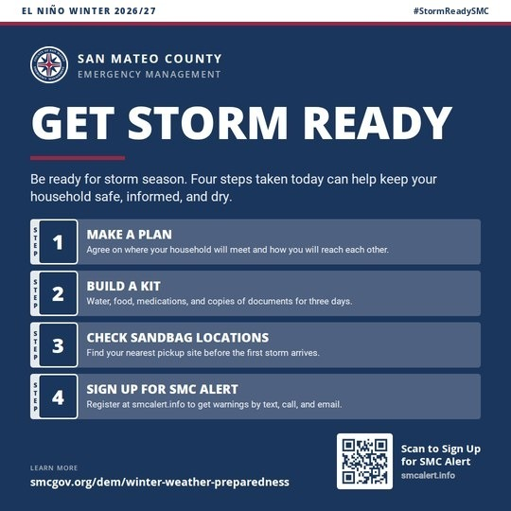 | Files: 01_get_storm_ready_square.png, 01_get_storm_ready_landscape.png  Alt text: Graphic from San Mateo County Emergency Management, El Niño Winter 2026/27. Headline: Get storm ready. Be ready for storm season. Four steps taken today can help keep your household safe, informed, and dry. Step 1, Make a Plan: Agree on where your household will meet and how you will reach each other. Step 2, Build a Kit: Water, food, medications, and copies of documents for three days. Step 3, Check Sandbag Locations: Find your nearest pickup site before the first storm arrives. Step 4, Sign Up for SMC Alert: Register at smcalert.info to get warnings by text, call, and email. QR code links to smcalert.info.
Five Elements Check
Agency | Hazard and Impacts | Location | Protective Action | Time
[AGENCY] | Very strong El Niño; flooding and storm damage | [LOCATION] | Plan, kit, sandbags, SMC Alert | This winter; before the first storm
Note: Step 3 points to sandbag sites. Before posting, the winter weather page needs either confirmed sites or a clear line saying when sites will be posted.

02. Sign Up for SMC Alert (and Update Your Info)
When | Week of Oct 5. Repeat week of Nov 9 and monthly through March.
Who posts | All partners.
Audience | Everyone; people who moved recently; Nixle subscribers
Short Post (X, Bluesky, Threads)
[AGENCY]: El Niño storms could bring flooding and power outages to [LOCATION] this winter. SIGN UP for SMC Alert now, or UPDATE your address and phone if you've moved: smcalert.info #StormReadySMC
196 characters as written (206 on X, where links count as 23).
Long Post (Facebook, Instagram, Nextdoor, LinkedIn)
[AGENCY]: Forecasters expect a very strong El Niño this winter, which raises the odds of flooding, high winds, and power outages in [LOCATION]. When a storm hits, SMC Alert is how San Mateo County sends warnings for your address by text, phone call, and email.
SIGN UP before the first storm at smcalert.info. Already signed up? CHECK that your address, phone number, and email are current. Warnings can only reach you if your information is right. Get our local updates on Nixle? That's separate, so sign up for SMC Alert too. And check that emergency alerts are turned on in your phone's settings; if a Wireless Emergency Alert comes in, act on it.
Then help 1 other person sign up: a parent, a neighbor, a coworker. #StormReadySMC
Graphic and Alt Text
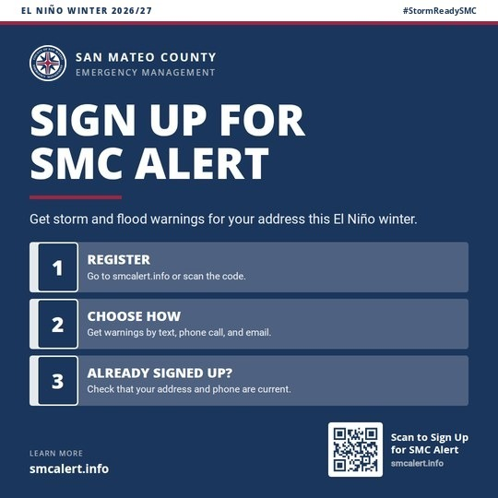 | Files: 02_smc_alert_square.png, 02_smc_alert_landscape.png  Alt text: Graphic from San Mateo County Emergency Management, El Niño Winter 2026/27. Headline: Sign up for SMC Alert. Get storm and flood warnings for your address this El Niño winter. Register: Go to smcalert.info or scan the code. Choose how: Get warnings by text, phone call, and email. Already signed up? Check that your address and phone are current. QR code links to smcalert.info. Website: smcalert.info.
Five Elements Check
Agency | Hazard and Impacts | Location | Protective Action | Time
[AGENCY] | El Niño storms; flooding and outages | [LOCATION] | Sign up or update info | Now; before the first storm
Note: Opt in alert systems depend on people keeping their information current, so every SMC Alert post asks for an update, not just a sign up. Partners that use Nixle: drop the Nixle sentence only if you don't run a Nixle channel.

03. Make a Plan
When | Week of Oct 12.
Who posts | All partners.
Audience | Households and families
Short Post (X, Bluesky, Threads)
[AGENCY]: Where will your loved ones be when a flood hits? El Niño storms could knock out phones and close roads in [LOCATION] this winter. MAKE A PLAN now: where your household meets, how you'll reach each other, and an out of area contact. #StormReadySMC
256 characters as written (256 on X, where links count as 23).
Long Post (Facebook, Instagram, Nextdoor, LinkedIn)
[AGENCY]: Where will your loved ones be when a flood hits? Forecasters expect a very strong El Niño this winter. Storms can close roads, cut power, and overload phone networks in [LOCATION], sometimes with little notice. MAKE A PLAN before the first storm:
• Pick a place to meet if you can't get home.
• Choose an out of area contact everyone can call or text.
• Know 2 ways out of your neighborhood.
• Look up your evacuation zone at protect.genasys.com.
A short conversation now means no one has to guess later. Planning help: ready.gov/plan #StormReadySMC
Graphic and Alt Text
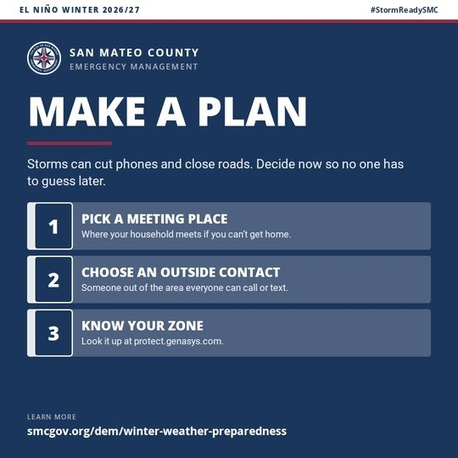 | Files: 03_make_a_plan_square.png, 03_make_a_plan_landscape.png  Alt text: Graphic from San Mateo County Emergency Management, El Niño Winter 2026/27. Headline: Make a plan. Storms can cut phones and close roads. Decide now so no one has to guess later. Pick a meeting place: Where your household meets if you can't get home. Choose an outside contact: Someone out of the area everyone can call or text. Know your zone: Look it up at protect.genasys.com. Website: smcgov.org/dem/winter-weather-preparedness.
Five Elements Check
Agency | Hazard and Impacts | Location | Protective Action | Time
[AGENCY] | El Niño storms; phone and road outages | [LOCATION] | Make a household plan | Now; before the first storm

04. Build a Kit
When | Week of Oct 19. Repeat week of Dec 7 with a give a kit angle for the holidays.
Who posts | All partners.
Audience | Households; people who live alone
Short Post (X, Bluesky, Threads)
[AGENCY]: El Niño storms could cut power or close roads in [LOCATION] for days this winter. BUILD A KIT now: water, food, medications, chargers, and copies of documents for 3 days. ready.gov/kit #StormReadySMC
209 characters as written (219 on X, where links count as 23).
Long Post (Facebook, Instagram, Nextdoor, LinkedIn)
[AGENCY]: Forecasters expect a very strong El Niño this winter. If a storm cuts power or closes roads in [LOCATION], you may need to get by on your own for a few days. BUILD A KIT before the first storm:
• Water and food for 3 days
• Medications and medical supplies
• Flashlight, batteries, a hand crank or battery radio, and a car or solar phone charger or power bank
• Copies of IDs, insurance, and other important documents in a waterproof bag, plus password protected digital copies
• Supplies for pets
Start with what you already have at home and fill the gaps a little at a time. Checklist: ready.gov/kit. Share this with someone who lives alone. #StormReadySMC
Graphic and Alt Text
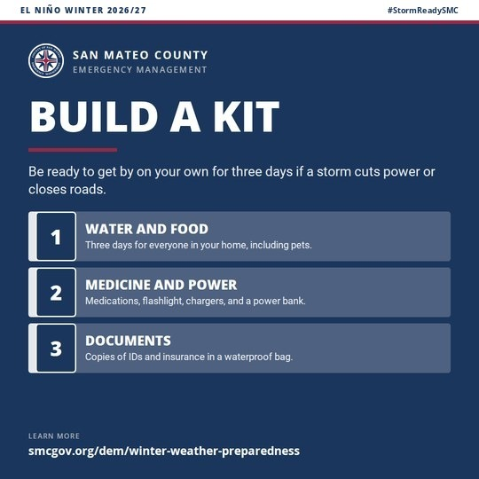 | Files: 04_build_a_kit_square.png, 04_build_a_kit_landscape.png  Alt text: Graphic from San Mateo County Emergency Management, El Niño Winter 2026/27. Headline: Build a kit. Be ready to get by on your own for three days if a storm cuts power or closes roads. Water and food: Three days for everyone in your home, including pets. Medicine and power: Medications, flashlight, chargers, and a power bank. Documents: Copies of IDs and insurance in a waterproof bag. Website: smcgov.org/dem/winter-weather-preparedness.
Five Elements Check
Agency | Hazard and Impacts | Location | Protective Action | Time
[AGENCY] | El Niño storms; outages and road closures | [LOCATION] | Build a 3 day kit | Now; before the first storm

05. Pick Up Sandbags Early (HOLD)
When | HOLD until Public Works confirms sites and hours. Then the first week they're posted.
Who posts | All partners; Public Works and flood control partners where possible.
Audience | Residents on flood prone streets and in low lying homes
Short Post (X, Bluesky, Threads)
[AGENCY]: El Niño storms could bring street flooding to [LOCATION] this winter. PICK UP sandbags before the first storm, while supplies are easy to get. Sites and hours: smcgov.org/dem/winter-weather-preparedness #StormReadySMC
227 characters as written (208 on X, where links count as 23).
Long Post (Facebook, Instagram, Nextdoor, LinkedIn)
[AGENCY]: Forecasters expect a very strong El Niño this winter, which raises the odds of heavy rain and street flooding in [LOCATION]. If water has come near your doors or garage before, PICK UP sandbags now, before the first storm, while lines are short and supplies are full.
Place them to steer water away from doors, garage entries, and low vents. Sandbags slow water down; they don't stop it, so move valuables off the floor in flood prone rooms.
Sites and hours: smcgov.org/dem/winter-weather-preparedness. Can't lift them? Ask a neighbor for help, or offer yours. #StormReadySMC
Graphic and Alt Text
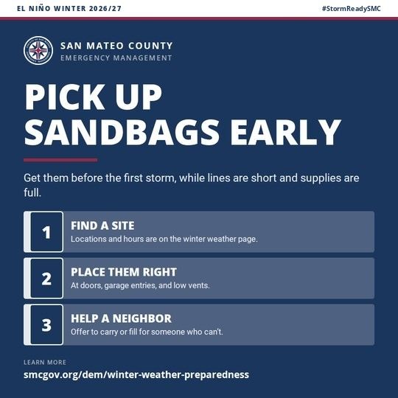 | Files: 05_sandbags_square.png, 05_sandbags_landscape.png  Alt text: Graphic from San Mateo County Emergency Management, El Niño Winter 2026/27. Headline: Pick up sandbags early. Get them before the first storm, while lines are short and supplies are full. Find a site: Locations and hours are on the winter weather page. Place them right: At doors, garage entries, and low vents. Help a neighbor: Offer to carry or fill for someone who can't. Website: smcgov.org/dem/winter-weather-preparedness.
Five Elements Check
Agency | Hazard and Impacts | Location | Protective Action | Time
[AGENCY] | El Niño storms; street flooding | [LOCATION] | Pick up and place sandbags | Now; before the first storm
Note: Don't post until sandbag sites and hours are live on the winter weather page. Never post sites from memory or past years.

06. Clear Gutters and Storm Drains
When | Week of Oct 26. Repeat before the first forecast storm and monthly through February.
Who posts | All partners; public works, fire, and sanitary districts especially.
Audience | Homeowners, renters, neighborhood groups
Short Post (X, Bluesky, Threads)
[AGENCY]: One blocked storm drain can flood a whole block in [LOCATION]. Before El Niño storms arrive this winter, CLEAR leaves from your gutters, downspouts, and the drain nearest your home. #StormReadySMC
206 characters as written (206 on X, where links count as 23).
Long Post (Facebook, Instagram, Nextdoor, LinkedIn)
[AGENCY]: Forecasters expect a very strong El Niño this winter. When heavy rain hits [LOCATION], blocked storm drains are one of the most common causes of street flooding, and the water doesn't stop at one house. Your neighbors are counting on everyone to do their part. Before the first storm:
• CLEAR leaves and debris from gutters and downspouts.
• CLEAR the storm drain nearest your home. Use a rake, and never lift a grate.
• Point downspouts away from your foundation.
• Water in your basement or crawl space before? Ask about a backflow valve, a water alarm, or a sump pump with battery backup.
See a drain that stays clogged? Report it to [PUBLIC WORKS CONTACT]. Share this in your street's group chat. #StormReadySMC
Graphic and Alt Text
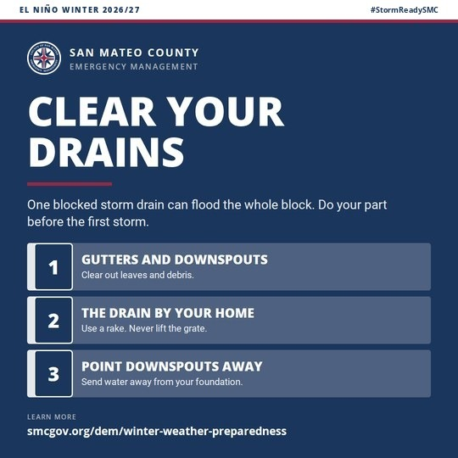 | Files: 06_clear_drains_square.png, 06_clear_drains_landscape.png  Alt text: Graphic from San Mateo County Emergency Management, El Niño Winter 2026/27. Headline: Clear your drains. One blocked storm drain can flood the whole block. Do your part before the first storm. Gutters and downspouts: Clear out leaves and debris. The drain by your home: Use a rake. Never lift the grate. Point downspouts away: Send water away from your foundation. Website: smcgov.org/dem/winter-weather-preparedness.
Five Elements Check
Agency | Hazard and Impacts | Location | Protective Action | Time
[AGENCY] | El Niño rain; street flooding | [LOCATION] | Clear gutters and drains | Before the first storm
Note: Messages that say what the community expects ("your neighbors are counting on you") have moved people more than messages about what most people do.

07. Check Your Flood Coverage
When | Week of Oct 12, repeat week of Oct 19. Time sensitive: a policy bought by about Oct 25 is typically in force for the Nov 24 King Tides.
Who posts | All partners; chambers and water districts reach homeowners well.
Audience | Homeowners and renters, especially near creeks, the Bay, and the coast
Short Post (X, Bluesky, Threads)
[AGENCY]: Most home and renters policies don't cover flooding, and new flood policies usually take 30 days to start. With El Niño storms possible in [LOCATION], CHECK your coverage this month: floodsmart.gov #StormReadySMC
222 characters as written (231 on X, where links count as 23).
Long Post (Facebook, Instagram, Nextdoor, LinkedIn)
[AGENCY]: Forecasters expect a very strong El Niño this winter, which raises the odds of flooding in [LOCATION]. Here's what many people don't know: standard homeowners and renters insurance typically doesn't cover flood damage.
Flood coverage comes through the National Flood Insurance Program or private insurers, and most new policies take about 30 days to take effect. FEMA estimates just a few inches of water in a 1,000 square foot home could cost more than $10,000 in repairs and replaced belongings. That means the time to act is now, before the storms. CALL your insurance agent this month, or learn more at floodsmart.gov. Renters can insure their belongings too.
Share this with a neighbor near a creek, the Bay, or the shoreline. #StormReadySMC
Graphic and Alt Text
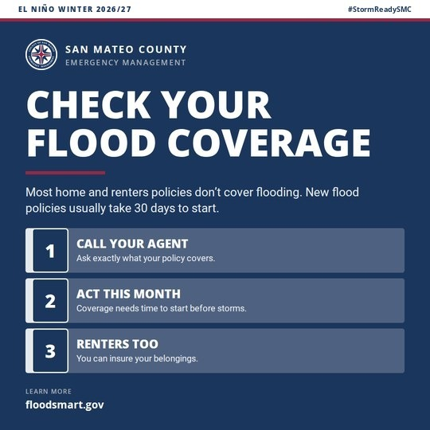 | Files: 07_flood_insurance_square.png, 07_flood_insurance_landscape.png  Alt text: Graphic from San Mateo County Emergency Management, El Niño Winter 2026/27. Headline: Check your flood coverage. Most home and renters policies don't cover flooding. New flood policies usually take 30 days to start. Call your agent: Ask exactly what your policy covers. Act this month: Coverage needs time to start before storms. Renters too: You can insure your belongings. Website: floodsmart.gov.
Five Elements Check
Agency | Hazard and Impacts | Location | Protective Action | Time
[AGENCY] | El Niño flooding; uninsured damage | [LOCATION] | Check or buy flood coverage | This month; 30 day waiting period
Note: Don't advise on individual policies. Point people to their agent and floodsmart.gov.

08. Know Your Flood Risk (New Residents)
When | Week of Oct 19. Repeat in January.
Who posts | All partners; city, HOA, and property manager channels reach new residents well.
Audience | People new to the area or who haven't lived through a strong El Niño here
Short Post (X, Bluesky, Threads)
[AGENCY]: New to [LOCATION]? A very strong El Niño could bring flooding near creeks, low streets, and the shoreline this winter. CHECK your flood risk and evacuation zone now: protect.genasys.com #StormReadySMC
210 characters as written (214 on X, where links count as 23).
Long Post (Facebook, Instagram, Nextdoor, LinkedIn)
[AGENCY]: If you were here for the January 2023 storms, you remember the flooding, downed trees, and outages across the county. If you weren't, now is the time to learn your risk. Forecasters expect a very strong El Niño this winter, which raises the odds of heavy rain and high tide flooding in [LOCATION]. And flooding doesn't follow lines on a map: where it can rain, it can flood.
Before the first storm:
• LOOK UP your evacuation zone at protect.genasys.com and write it down.
• CHECK your address on FEMA's flood map at msc.fema.gov.
• ASK a longtime neighbor where water collects on your street.
Knowing your zone means you'll know right away when an alert is for you. #StormReadySMC
Graphic and Alt Text
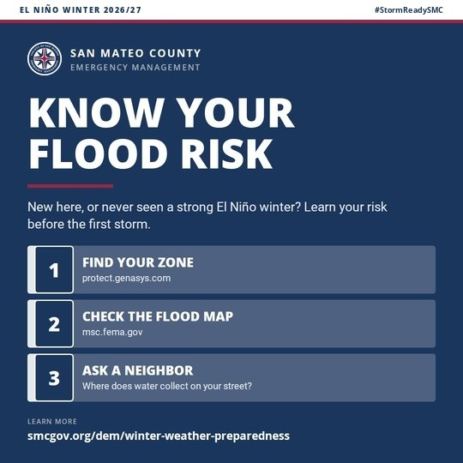 | Files: 08_flood_risk_square.png, 08_flood_risk_landscape.png  Alt text: Graphic from San Mateo County Emergency Management, El Niño Winter 2026/27. Headline: Know your flood risk. New here, or never seen a strong El Niño winter? Learn your risk before the first storm. Find your zone: protect.genasys.com. Check the flood map: msc.fema.gov. Ask a neighbor: Where does water collect on your street? Website: smcgov.org/dem/winter-weather-preparedness.
Five Elements Check
Agency | Hazard and Impacts | Location | Protective Action | Time
[AGENCY] | El Niño flooding | [LOCATION]; creeks, low streets, shoreline | Check flood risk and zone | Before the first storm
Note: People who've lived through a flood take the risk more seriously. Naming a storm people remember (January 2023) connects to that experience; for newcomers, the post supplies what experience would have taught.

09. Plan for Extra Help (Older Adults and People with Disabilities)
When | Week of Oct 26. Repeat in December.
Who posts | All partners; share with senior centers, faith groups, independent living centers, and caregiver networks.
Audience | Older adults, people with disabilities, people who use power dependent equipment, and caregivers
Short Post (X, Bluesky, Threads)
[AGENCY]: If you or someone you care for in [LOCATION] uses powered medical equipment or needs help to leave home, PLAN now for El Niño storms this winter: who will help, and how. #StormReadySMC
194 characters as written (194 on X, where links count as 23).
Long Post (Facebook, Instagram, Nextdoor, LinkedIn)
[AGENCY]: Forecasters expect a very strong El Niño this winter. Storms can cut power and close roads in [LOCATION], and they hit hardest for people who need extra time or help. If that's you or someone you care for, PLAN now, before the first storm:
• Line up 2 people who will check on you and help you leave if needed.
• Keep a week's supply of medications and a list of prescriptions and doctors.
• If you use powered medical equipment, have a backup battery and a plan for where to go if the power is out for a long time.
• SIGN UP for SMC Alert at smcalert.info and share your plan with your helpers.
Caregivers and family: make this plan together this month. #StormReadySMC
Graphic and Alt Text
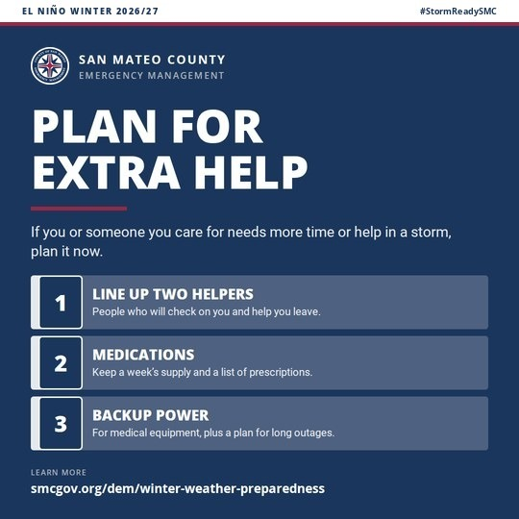 | Files: 09_extra_help_square.png, 09_extra_help_landscape.png  Alt text: Graphic from San Mateo County Emergency Management, El Niño Winter 2026/27. Headline: Plan for extra help. If you or someone you care for needs more time or help in a storm, plan it now. Line up two helpers: People who will check on you and help you leave. Medications: Keep a week's supply and a list of prescriptions. Backup power: For medical equipment, plus a plan for long outages. Website: smcgov.org/dem/winter-weather-preparedness.
Five Elements Check
Agency | Hazard and Impacts | Location | Protective Action | Time
[AGENCY] | El Niño storms; outages and road closures | [LOCATION] | Make a plan with helpers | Now; this month

10. Check on Each Other
When | Week of Oct 26. Repeat week of Nov 9 and before major forecast storms.
Who posts | All partners; CBOs, faith communities, and neighborhood associations especially.
Audience | Everyone; neighborhood groups
Short Post (X, Bluesky, Threads)
[AGENCY]: When El Niño storms reach [LOCATION] this winter, the fastest warning is often a person. Before the storms, TRADE numbers with a neighbor and agree to check on each other when an alert goes out. #StormReadySMC
219 characters as written (219 on X, where links count as 23).
Long Post (Facebook, Instagram, Nextdoor, LinkedIn)
[AGENCY]: Forecasters expect a very strong El Niño this winter. Research on warnings shows that hearing about a threat from someone you know is one of the best ways to get people moving, and not everyone gets alerts on their phone. Before storms reach [LOCATION]:
• TRADE phone numbers with at least 1 neighbor.
• AGREE to call or knock when an alert goes out for your area.
• KNOW who on your street lives alone or has limited mobility.
When an alert comes, pass it on. #StormReadySMC
Graphic and Alt Text
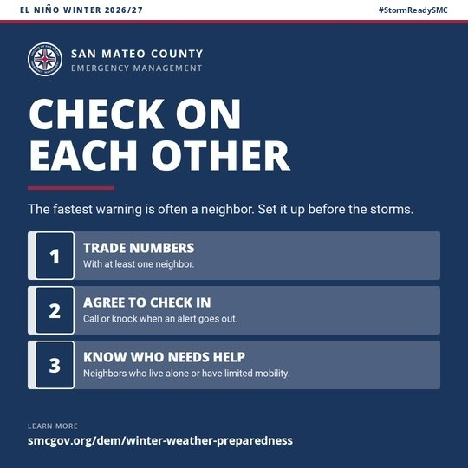 | Files: 10_check_on_neighbors_square.png, 10_check_on_neighbors_landscape.png  Alt text: Graphic from San Mateo County Emergency Management, El Niño Winter 2026/27. Headline: Check on each other. The fastest warning is often a neighbor. Set it up before the storms. Trade numbers: With at least one neighbor. Agree to check in: Call or knock when an alert goes out. Know who needs help: Neighbors who live alone or have limited mobility. Website: smcgov.org/dem/winter-weather-preparedness.
Five Elements Check
Agency | Hazard and Impacts | Location | Protective Action | Time
[AGENCY] | El Niño storms | [LOCATION] | Set up neighbor check ins | Before the storms; when an alert goes out

18. Coastside: Plan for Closed Roads
When | Week of Nov 2. Repeat 24 to 72 hours before any storm forecast to bring heavy rain to the coast.
Who posts | Coastside partners: Pacifica, Half Moon Bay, coastal fire and law, unincorporated Coastside communities, school districts, and CBOs.
Audience | Coastside residents and commuters, including Pescadero, La Honda, and the Midcoast
Short Post (X, Bluesky, Threads)
[AGENCY]: El Niño storms can close Highways 1, 92, and 84 this winter, and parts of the Coastside can be cut off for a while. STOCK UP on 3 days of food, water, meds, and fuel, and LEAVE EARLY if you need to go. #StormReadySMC
226 characters as written (226 on X, where links count as 23).
Long Post (Facebook, Instagram, Nextdoor, LinkedIn)
[AGENCY]: Forecasters expect a very strong El Niño this winter. When heavy rain hits the Coastside, slides and flooding can close Highways 1, 92, and 84, and help and supplies may take longer to reach [LOCATION]. Before the first storm:
• STOCK UP on at least 3 days of food, water, medications, and pet supplies.
• FILL your tank or charge your car when a big storm is forecast.
• PLAN for kids at school or family working over the hill if roads close midday.
• CHECK road conditions at quickmap.dot.ca.gov or call 1-800-427-7623 before you drive.
If you may need to leave, go before the storm, not during it. Sign up for SMC Alert at smcalert.info. #StormReadySMC
Graphic and Alt Text
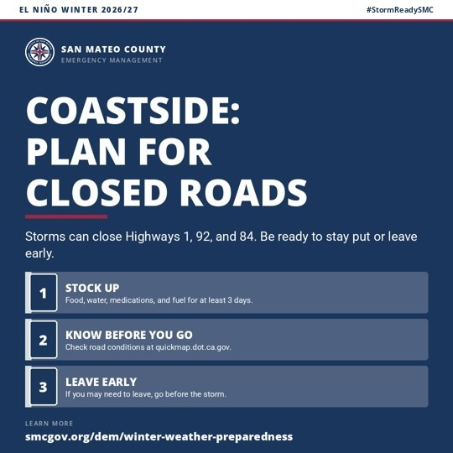 | Files: 18_coastside_roads_square.png, 18_coastside_roads_landscape.png  Alt text: Graphic from San Mateo County Emergency Management, El Niño Winter 2026/27. Headline: Coastside: plan for closed roads. Storms can close Highways 1, 92, and 84. Be ready to stay put or leave early. Stock up: Food, water, medications, and fuel for at least 3 days. Know before you go: Check road conditions at quickmap.dot.ca.gov. Leave early: If you may need to leave, go before the storm. Website: smcgov.org/dem/winter-weather-preparedness.
Five Elements Check
Agency | Hazard and Impacts | Location | Protective Action | Time
[AGENCY] | Storm closures of Hwy 1, 92, 84; isolation | Coastside; [LOCATION] | Stock up; check roads; leave early | Before the first storm; before any big storm
Note: Coastside partners can add local supply points or community centers in [LOCATION]. FEMA's Commuter Emergency Plan fits commuters well; the link is in the FEMA and Ready.gov Resources section. Open it before you post it.

19. Check Your Trees
When | Week of Oct 26. Repeat before forecast wind storms.
Who posts | All partners; fire, public works, and utilities especially.
Audience | Homeowners, renters, property managers, HOAs
Short Post (X, Bluesky, Threads)
[AGENCY]: Soaked ground and strong wind can bring down trees in [LOCATION] this winter. HAVE large trees near your home checked by a certified arborist now, before crews book up. #StormReadySMC
193 characters as written (193 on X, where links count as 23).
Long Post (Facebook, Instagram, Nextdoor, LinkedIn)
[AGENCY]: Forecasters expect a very strong El Niño this winter. When soil is soaked and the wind picks up, trees in [LOCATION] can fall on homes, cars, roads, and power lines. Before the storms:
• LOOK for cracks in the trunk, dead or hanging branches, new leaning, or roots lifting the soil.
• CALL a certified arborist to check large trees near your home. Crews book up fast once storms start.
• RENTERS: tell your landlord or property manager about any tree that worries you.
After a storm, stay clear of downed trees, and never touch a tree or branch tangled in power lines. Report trees blocking the road to [PUBLIC WORKS CONTACT]. #StormReadySMC
Graphic and Alt Text
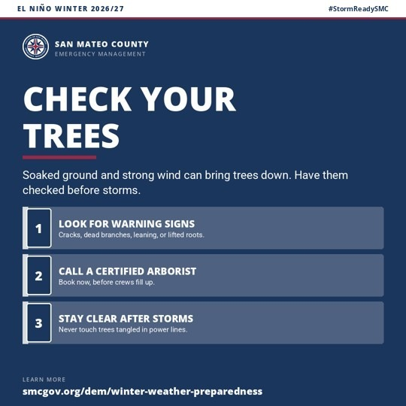 | Files: 19_trees_wind_square.png, 19_trees_wind_landscape.png  Alt text: Graphic from San Mateo County Emergency Management, El Niño Winter 2026/27. Headline: Check your trees. Soaked ground and strong wind can bring trees down. Have them checked before storms. Look for warning signs: Cracks, dead branches, leaning, or lifted roots. Call a certified arborist: Book now, before crews fill up. Stay clear after storms: Never touch trees tangled in power lines. Website: smcgov.org/dem/winter-weather-preparedness.
Five Elements Check
Agency | Hazard and Impacts | Location | Protective Action | Time
[AGENCY] | Falling trees; wind and soaked soil | [LOCATION] | Get trees checked; stay clear after | Now; before and after storms
Note: Don't recommend topping or heavy thinning; arborists warn both can make trees less safe.

20. Businesses: Don't Let Your Business End Up in a Dumpster
When | Week of Nov 2.
Who posts | Cities, economic development, chambers of commerce, and business associations.
Audience | Small business owners and managers
Short Post (X, Bluesky, Threads)
[AGENCY]: Don't let your business end up in a dumpster. A flooded shop or a long outage can close a [LOCATION] business for days. Before El Niño storms, BACK UP records, MOVE stock off the floor, and CHECK what your insurance covers. #StormReadySMC
248 characters as written (248 on X, where links count as 23).
Long Post (Facebook, Instagram, Nextdoor, LinkedIn)
[AGENCY]: Don't let your business end up in a dumpster. Forecasters expect a very strong El Niño this winter. For small businesses in [LOCATION], a few inches of water or a few days without power can mean lost stock, lost pay for staff, and customers who don't come back. Before the first storm:
• BACK UP customer, payroll, and vendor records off site or in the cloud.
• MOVE inventory, equipment, and electronics off the floor in flood prone spaces.
• CHECK your policy for flood, business interruption, and spoilage coverage.
• ASK every employee to sign up for SMC Alert at smcalert.info and agree how you'll reach each other.
Ready businesses reopen faster, and that keeps [LOCATION] working. #StormReadySMC
Graphic and Alt Text
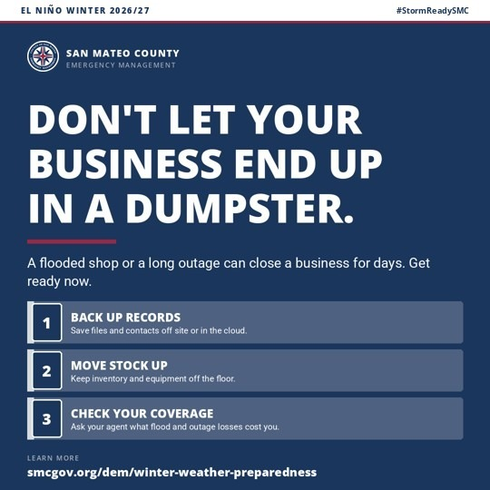 | Files: 20_business_ready_square.png, 20_business_ready_landscape.png  Alt text: Graphic from San Mateo County Emergency Management, El Niño Winter 2026/27. Headline: Don't let your business end up in a dumpster. A flooded shop or a long outage can close a business for days. Get ready now. Back up records: Save files and contacts off site or in the cloud. Move stock up: Keep inventory and equipment off the floor. Check your coverage: Ask your agent what flood and outage losses cost you. Website: smcgov.org/dem/winter-weather-preparedness.
Five Elements Check
Agency | Hazard and Impacts | Location | Protective Action | Time
[AGENCY] | Flooding and outages; business closure | [LOCATION] | Back up, move stock, check coverage | Before the first storm
Note: The headline is adapted from FEMA's Ready.gov flood toolkit.

21. Families and Schools: School Day Storm Plan
When | Week of Oct 12, after the Sept 25 County Office of Education call. Repeat in January.
Who posts | School districts, the County Office of Education, PTAs, child care providers, and all partners.
Audience | Parents and caregivers of school age children
Short Post (X, Bluesky, Threads)
[AGENCY]: Parents in [LOCATION]: if an El Niño storm closes roads during the school day, who picks up your kids? UPDATE your school emergency contacts and NAME a backup adult now. #StormReadySMC
194 characters as written (194 on X, where links count as 23).
Long Post (Facebook, Instagram, Nextdoor, LinkedIn)
[AGENCY]: Forecasters expect a very strong El Niño this winter. A storm that closes roads in [LOCATION] during the school day can keep parents from reaching pickup on time. Take care of it now:
• UPDATE your emergency contacts with your child's school.
• NAME a backup adult nearby who's authorized to pick up your kids.
• KNOW how your school sends messages, and sign up for SMC Alert at smcalert.info.
• TALK with your kids: stay out of creeks, storm drains, and flood water, even when it looks shallow.
A 10 minute call now saves a scramble later. #StormReadySMC
Graphic and Alt Text
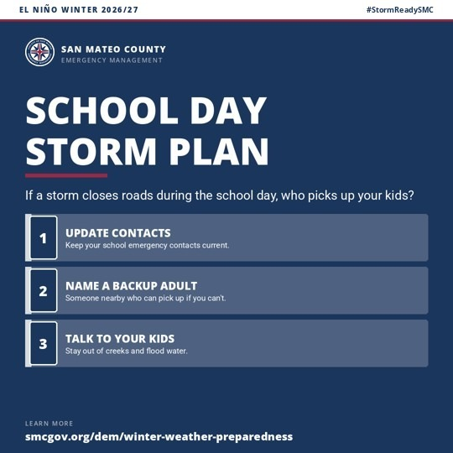 | Files: 21_families_schools_square.png, 21_families_schools_landscape.png  Alt text: Graphic from San Mateo County Emergency Management, El Niño Winter 2026/27. Headline: School day storm plan. If a storm closes roads during the school day, who picks up your kids? Update contacts: Keep your school emergency contacts current. Name a backup adult: Someone nearby who can pick up if you can't. Talk to your kids: Stay out of creeks and flood water. Website: smcgov.org/dem/winter-weather-preparedness.
Five Elements Check
Agency | Hazard and Impacts | Location | Protective Action | Time
[AGENCY] | Storm road closures during school hours | [LOCATION] | Update contacts; name backup adult | Now; before the first storm
Note: Schools should add their own notification system name in place of "how your school sends messages."

22. Pack a Pet Go Bag
When | Week of Oct 19.
Who posts | All partners; animal services, shelters, and veterinary partners especially.
Audience | Pet owners; owners of horses and livestock on the Coastside and in rural areas
Short Post (X, Bluesky, Threads)
[AGENCY]: If you have to leave home during an El Niño storm this winter, take your pets. PACK a pet go bag now: leash, carrier, food, water, meds, and a photo of you with your pet. #StormReadySMC
195 characters as written (195 on X, where links count as 23).
Long Post (Facebook, Instagram, Nextdoor, LinkedIn)
[AGENCY]: Forecasters expect a very strong El Niño this winter. If you have to leave [LOCATION] in a hurry, your pets should leave with you. PACK a pet go bag before the first storm:
• Leash, carrier, food, water, and bowls
• Medications and vet records
• Litter and a litter box for cats
• Current ID tags, microchip information, and a recent photo of you with your pet
Have horses or livestock? Plan now where they'll go and how you'll move them. Waiting for the storm is too late. #StormReadySMC
Graphic and Alt Text
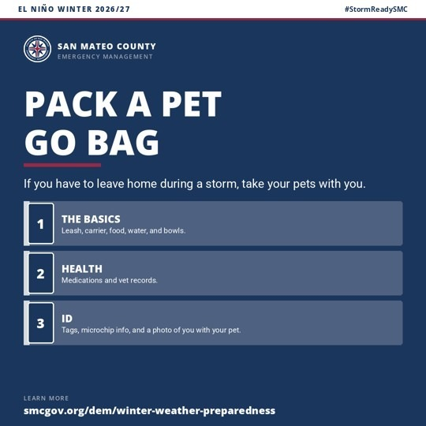 | Files: 22_pets_ready_square.png, 22_pets_ready_landscape.png  Alt text: Graphic from San Mateo County Emergency Management, El Niño Winter 2026/27. Headline: Pack a pet go bag. If you have to leave home during a storm, take your pets with you. The basics: Leash, carrier, food, water, and bowls. Health: Medications and vet records. ID: Tags, microchip info, and a photo of you with your pet. Website: smcgov.org/dem/winter-weather-preparedness.
Five Elements Check
Agency | Hazard and Impacts | Location | Protective Action | Time
[AGENCY] | Storm evacuation with pets | [LOCATION] | Pack a pet go bag | Now; before the first storm

23. Record Your Stuff
When | Week of Oct 26. Repeat in December.
Who posts | All partners; chambers, libraries, and insurance and consumer groups reach people well.
Audience | Homeowners and renters
Short Post (X, Bluesky, Threads)
[AGENCY]: Before El Niño storms reach [LOCATION], take 10 minutes to RECORD a video walk through of your home, including drawers and closets. Email it to yourself. It makes insurance claims much easier. #StormReadySMC
217 characters as written (217 on X, where links count as 23).
Long Post (Facebook, Instagram, Nextdoor, LinkedIn)
[AGENCY]: Forecasters expect a very strong El Niño this winter. If a storm damages your home in [LOCATION], proving what you owned is one of the hardest parts of a claim. Take 10 minutes this week:
• RECORD a video of every room on your phone, narrating as you go.
• OPEN drawers and closets, and capture serial numbers on electronics and appliances.
• SAVE a copy by emailing it to yourself or storing it online.
Renters, this matters for you too. #StormReadySMC
Graphic and Alt Text
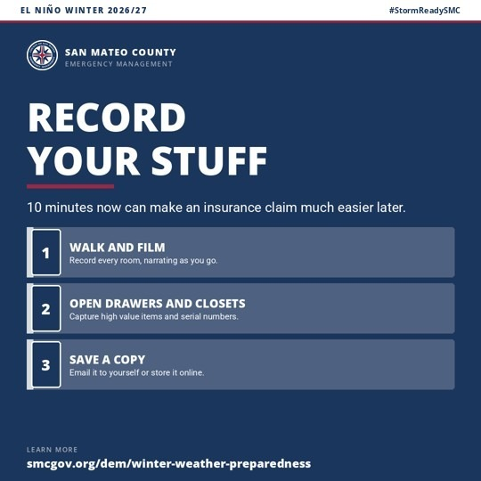 | Files: 23_record_your_stuff_square.png, 23_record_your_stuff_landscape.png  Alt text: Graphic from San Mateo County Emergency Management, El Niño Winter 2026/27. Headline: Record your stuff. 10 minutes now can make an insurance claim much easier later. Walk and film: Record every room, narrating as you go. Open drawers and closets: Capture high value items and serial numbers. Save a copy: Email it to yourself or store it online. Website: smcgov.org/dem/winter-weather-preparedness.
Five Elements Check
Agency | Hazard and Impacts | Location | Protective Action | Time
[AGENCY] | Storm damage; hard to prove losses | [LOCATION] | Record a home inventory video | This week; before the first storm

24. Before the First Storm: Check These 4
When | Week of Oct 12. Repeat week of Oct 19. Time sensitive: flood coverage started by Oct 25 is typically in force for the Nov 24 King Tides.
Who posts | All partners; public works, insurance and consumer groups, and chambers reach people well.
Audience | Households that have taken the 4 steps and are ready for the next ones
Short Post (X, Bluesky, Threads)
[AGENCY]: Before the first El Niño storm reaches [LOCATION], check these 4: flood insurance, tires, gutters and drains, and trees. Start flood coverage by Oct 25 to be covered for the Nov 24 King Tides. #StormReadySMC
217 characters as written (217 on X, where links count as 23).
Long Post (Facebook, Instagram, Nextdoor, LinkedIn)
[AGENCY]: You've made a plan, built a kit, found your sandbag site, and signed up for SMC Alert. Before the first storm reaches [LOCATION], CHECK these 4 while the skies are clear:
• FLOOD INSURANCE: Standard homeowner and renter policies don't cover flood, and new flood policies usually take 30 days to start. Start by Oct 25 to be covered for the Nov 24 King Tides. Free guidance at uphelp.org.
• TIRES: Gas or electric, worn tread loses its grip on wet roads. Measure your tread, replace worn out wiper blades, and confirm your auto policy includes comprehensive coverage, which usually covers flood damage.
• GUTTERS, DRAINS, AND DEBRIS: Flooding often starts where leaves and trash pile up. Clear your own, then gather neighbors to clear your street and school.
• TREES: Have a certified arborist check large trees while it's dry. Renting? Ask your property manager to arrange it.
Details: smcgov.org/dem/winter-weather-preparedness. Share this with a neighbor. #StormReadySMC
Graphic and Alt Text
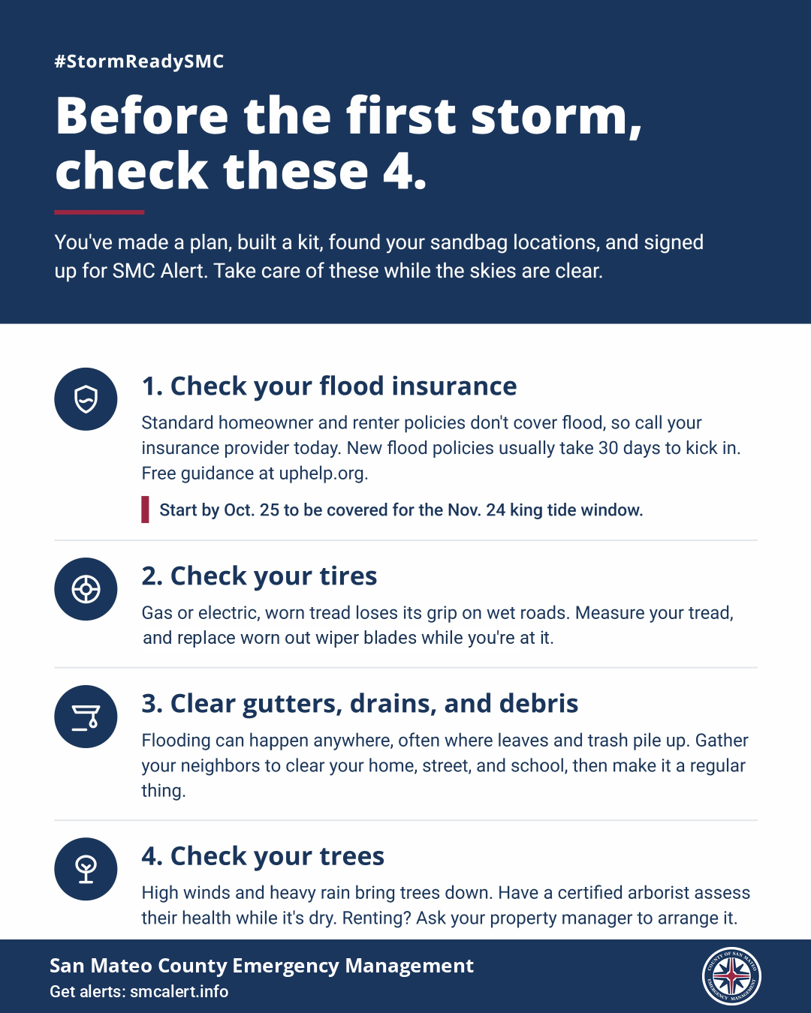 | Files: 24_check_these_4_portrait.png (1080 by 1350; portrait only) and the printable flyer  Alt text: Graphic from San Mateo County Emergency Management. #StormReadySMC. Headline: Before the first storm, check these 4. You've made a plan, built a kit, found your sandbag locations, and signed up for SMC Alert. Take care of these while the skies are clear. 1. Check your flood insurance: Standard homeowner and renter policies don't cover flood, so call your insurance provider today. New flood policies usually take 30 days to kick in. Free guidance at uphelp.org. Start by Oct. 25 to be covered for the Nov. 24 king tide window. 2. Check your tires: Gas or electric, worn tread loses its grip on wet roads. Measure your tread, and replace worn out wiper blades while you're at it. 3. Clear gutters, drains, and debris: Flooding can happen anywhere, often where leaves and trash pile up. Gather your neighbors to clear your home, street, and school, then make it a regular thing. 4. Check your trees: High winds and heavy rain bring trees down. Have a certified arborist assess their health while it's dry. Renting? Ask your property manager to arrange it.
Five Elements Check
Agency | Hazard and Impacts | Location | Protective Action | Time
[AGENCY] | El Niño storms; flooding, slick roads, falling trees | [LOCATION] | Check flood coverage, tires, drains, and trees | Before the first storm; flood coverage by Oct 25
Note: This is the next step after the 4 steps in 01, and it pulls together 06, 07, and 19 in one post. After Oct 25, drop the date line and keep the 30 day message. The graphic and flyer use "Oct." and "king tide"; the post text follows this kit's style, "Oct 25" and "King Tides."

Phase 2: King Tides
The week before each King Tide window: November, December, and January.

11. King Tides and Coastal Flooding
When | The week before each window: post by Nov 17 (Nov 24 to 26), Dec 15 (Dec 22 to 25), and Jan 13 (Jan 20 to 23). Repeat the day before each window starts.
Who posts | Bayside and coastal partners, including OneShoreline and shoreline cities. The Nov and Dec windows fall on Thanksgiving and Christmas travel.
Audience | Shoreline residents, walkers, cyclists, drivers on low Bay and coastal roads
Short Post (X, Bluesky, Threads)
[AGENCY]: King Tides, the highest tides of the year, reach [LOCATION] [DATES]. El Niño can push water higher. AVOID flooded shoreline roads and STAY BACK from waves. Tide times: coastal.ca.gov/kingtides #StormReadySMC
217 characters as written (216 on X, where links count as 23).
Long Post (Facebook, Instagram, Nextdoor, LinkedIn)
[AGENCY]: King Tides, the highest tides of the year, return to [LOCATION] [DATES]. This winter, El Niño can push water even higher than predicted, and a storm at the same time makes it worse. Expect water on low shoreline roads, parking lots, and trails around high tide.
• AVOID driving or walking through water on roads. It can hide damaged pavement.
• STAY BACK from the water's edge on beaches, bluffs, and jetties. Never turn your back on the ocean.
• MOVE cars out of low shoreline lots before high tide.
Check tide times near you: coastal.ca.gov/kingtides. Share with anyone who walks, bikes, or drives the shoreline. #StormReadySMC #KingTides
Graphic and Alt Text
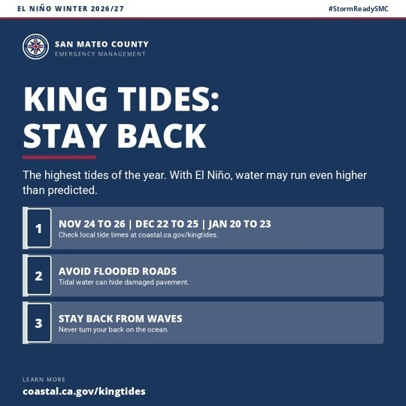 | Files: 11_king_tides_square.png, 11_king_tides_landscape.png  Alt text: Graphic from San Mateo County Emergency Management, El Niño Winter 2026/27. Headline: King Tides: stay back. The highest tides of the year. With El Niño, water may run even higher than predicted. Nov 24 to 26, Dec 22 to 25, Jan 20 to 23: Check local tide times at coastal.ca.gov/kingtides. Avoid flooded roads: Tidal water can hide damaged pavement. Stay back from waves: Never turn your back on the ocean. Website: coastal.ca.gov/kingtides.
Five Elements Check
Agency | Hazard and Impacts | Location | Protective Action | Time
[AGENCY] | King Tides plus El Niño; coastal flooding | [LOCATION]; shoreline roads and trails | Avoid flooded roads; stay back | [DATES]; around high tide
Note: Fill [DATES] as "Nov 24 to 26", "Dec 22 to 25", or "Jan 20 to 23". These windows include the Northern California dates the Coastal Commission lists and match the county's leadership brief. "King Tides" can sound like an event to go see, so every post pairs it with the hazard and an action.

Phase 3: Storm Watch
December through March, 24 to 72 hours before a forecast storm, plus monthly repeats. Once NWS issues a warning, switch to the Messaging Library.

12. Storm Coming: Do 3 Things Now
When | 24 to 72 hours before a forecast storm (NWS Flood Watch, Wind Advisory, or similar). Not for use once a warning is issued.
Who posts | All partners.
Audience | Everyone
Short Post (X, Bluesky, Threads)
[AGENCY]: A strong storm is expected in [LOCATION] [DAY/TIME], with heavy rain and gusty wind. Before it arrives: CHARGE phones, CLEAR the drain by your home, and SECURE outdoor items. #StormReadySMC
199 characters as written (199 on X, where links count as 23).
Long Post (Facebook, Instagram, Nextdoor, LinkedIn)
[AGENCY]: The National Weather Service expects a strong storm to reach [LOCATION] [DAY/TIME], bringing [HEAVY RAIN / STRONG WIND / HIGH SURF]. [LOCAL IMPACT]. Do 3 things before it arrives:
1. CHARGE phones and power banks, and find your flashlight.
2. CLEAR leaves from the storm drain and gutters by your home.
3. SECURE or bring in outdoor furniture, trash bins, and anything the wind can throw.
Make sure you're signed up at smcalert.info, and check [URL] for updates. If you live near a creek or on a steep slope, be ready to leave if told to, but never go into flood water to get out. If you're already on high ground, staying put may be safest. Tell a neighbor. #StormReadySMC
Graphic and Alt Text
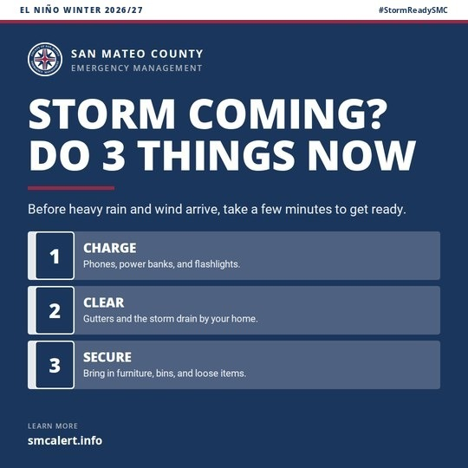 | Files: 12_storm_coming_square.png, 12_storm_coming_landscape.png  Alt text: Graphic from San Mateo County Emergency Management, El Niño Winter 2026/27. Headline: Storm coming? Do 3 things now. Before heavy rain and wind arrive, take a few minutes to get ready. Charge: Phones, power banks, and flashlights. Clear: Gutters and the storm drain by your home. Secure: Bring in furniture, bins, and loose items. Website: smcalert.info.
Five Elements Check
Agency | Hazard and Impacts | Location | Protective Action | Time
[AGENCY] | Strong storm; rain and wind | [LOCATION] | Charge, clear, secure | [DAY/TIME]; before it arrives
Note: [LOCAL IMPACT] example: "Low roads near San Francisquito Creek may flood." Take timing only from NWS Bay Area or SMC EM, never from national media. Once NWS issues a warning or a hazard is active, switch to the Alert and Warning Messaging Library.

13. Flooded Roads: Your GPS Doesn't Know the Road Is Gone
When | Before and during forecast heavy rain. Repeat monthly December through March, alternating the 2 versions.
Who posts | All partners; law, fire, public works, transit, and Caltrans partners especially.
Audience | All drivers and pedestrians; version B speaks to commuters and older drivers
Short Post (X, Bluesky, Threads)
[AGENCY]: Your GPS doesn't know the road is gone. When El Niño storms flood roads in [LOCATION], water can hide washed out pavement, and 12 inches of moving water can carry away most cars. DON'T DRIVE IN. #StormReadySMC
219 characters as written (219 on X, where links count as 23).
Short Post, Version B
[AGENCY]: Nobody plans to drive into a flood. They plan to get home. This winter in [LOCATION], if water covers the road, DON'T DRIVE IN. Find another route or wait it out. Home will still be there. #StormReadySMC
213 characters as written (213 on X, where links count as 23).
Long Post (Facebook, Instagram, Nextdoor, LinkedIn)
[AGENCY]: Your GPS doesn't know the road is gone. Forecasters expect a very strong El Niño this winter, and heavy rain can flood roads in [LOCATION] fast, especially near creeks and underpasses. Most flood deaths happen in vehicles. You can't tell how deep the water is or whether the road under it is still there, and it's even harder at night.
• 6 inches of moving water can knock an adult off their feet.
• 12 inches can carry away most cars.
• NEVER drive around barricades. Crews put them there to get people out of flooded areas.
• STAY OFF bridges over fast moving water.
If water covers the road, DON'T DRIVE IN. Find another route or wait it out. If your car is ever caught in fast moving water, stay inside, and get on the roof if water rises inside the car. #StormReadySMC
Graphic and Alt Text
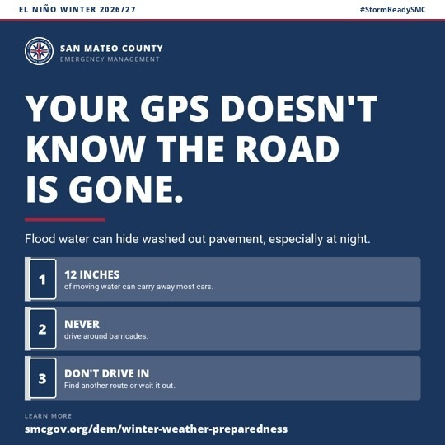 | Files: 13_flooded_roads_square.png, 13_flooded_roads_landscape.png  Alt text: Graphic from San Mateo County Emergency Management, El Niño Winter 2026/27. Headline: Your GPS doesn't know the road is gone. Flood water can hide washed out pavement, especially at night. 12 inches of moving water can carry away most cars. Never drive around barricades. Don't drive in: Find another route or wait it out. Website: smcgov.org/dem/winter-weather-preparedness.
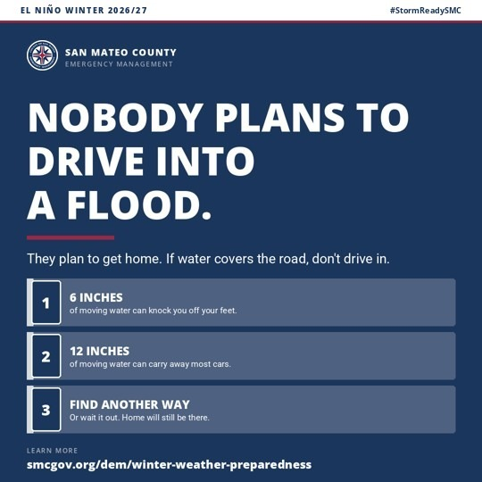 | Version B files: 13b_get_home_square.png, 13b_get_home_landscape.png  Alt text: Graphic from San Mateo County Emergency Management, El Niño Winter 2026/27. Headline: Nobody plans to drive into a flood. They plan to get home. If water covers the road, don't drive in. 6 inches of moving water can knock you off your feet. 12 inches of moving water can carry away most cars. Find another way, or wait it out. Home will still be there. Website: smcgov.org/dem/winter-weather-preparedness.
Five Elements Check
Agency | Hazard and Impacts | Location | Protective Action | Time
[AGENCY] | Flooded roads; drowning | [LOCATION]; creeks and underpasses | Don't drive in; never pass barricades | This winter; during heavy rain, especially at night
Note: Version A (GPS) runs with graphic 13; version B ("Nobody plans...") runs with graphic 13b. The depth figures come from the National Weather Service. The barricade, bridge, and trapped car guidance follows FEMA's Ready.gov flood page. Name the action plainly in every version: don't drive in.

14. Flooded Roads: Flood Water Totals Cars (Young Drivers)
When | Evenings before and during forecast heavy rain. Instagram and short video work best for this audience.
Who posts | Law partners, school resource officers, high schools, community colleges, and youth serving partners.
Audience | Drivers ages 18 to 35, the group most likely to drive into flood water
Short Post (X, Bluesky, Threads)
[AGENCY]: Flood water totals cars. Don't let it be yours. 6 inches can stall you, and 12 inches of moving water can carry your car away. This El Niño winter in [LOCATION], if water covers the road, DON'T DRIVE IN. #StormReadySMC
228 characters as written (228 on X, where links count as 23).
Long Post (Facebook, Instagram, Nextdoor, LinkedIn)
[AGENCY]: Flood water totals cars. Don't let it be yours. This winter's El Niño raises the odds of heavy rain in [LOCATION], and flooded roads are where most flood deaths happen, often at night.
• 6 inches of water can make you lose control or stall.
• 12 inches of moving water can carry your car away.
• At night you can't see how deep it is or whether the road is still there.
Your car can be replaced. You can't. If water covers the road, DON'T DRIVE IN. Take another way. Tag a friend who drives [ROAD OR AREA]. #StormReadySMC
Graphic and Alt Text
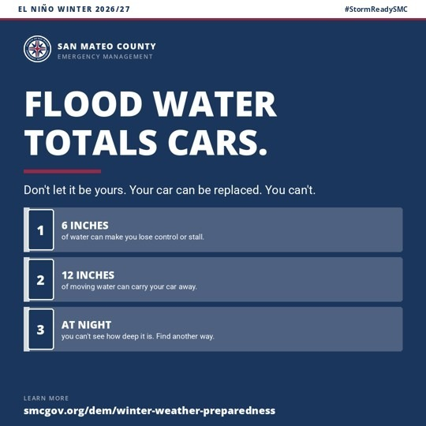 | Files: 14_not_worth_it_square.png, 14_not_worth_it_landscape.png  Alt text: Graphic from San Mateo County Emergency Management, El Niño Winter 2026/27. Headline: Flood water totals cars. Don't let it be yours. Your car can be replaced. You can't. 6 inches of water can make you lose control or stall. 12 inches of moving water can carry your car away. At night you can't see how deep it is. Find another way. Website: smcgov.org/dem/winter-weather-preparedness.
Five Elements Check
Agency | Hazard and Impacts | Location | Protective Action | Time
[AGENCY] | Flooded roads; car damage and drowning | [LOCATION]; [ROAD OR AREA] | Don't drive in; take another way | This winter; at night
Note: Young drivers often feel invincible but care about their cars, so this version leads with what flood water does to a car. Keep the same plain action in every version: don't drive in.

15. Power Outages and Generator Safety
When | Version B: week of Oct 19. Version A: before forecast wind storms and during extended outages.
Who posts | All partners; fire, utilities, and health partners especially.
Audience | Households with generators; anyone losing power; version B is for everyone before storms
Short Post (X, Bluesky, Threads)
[AGENCY]: El Niño storms can knock out power in [LOCATION] this winter. If you use a generator, RUN it outside only, at least 20 feet from windows and doors. Carbon monoxide can kill in minutes. #StormReadySMC
209 characters as written (209 on X, where links count as 23).
Short Post, Version B
[AGENCY]: Get your communication ON when the power's OFF. El Niño storms can cut power in [LOCATION] for days this winter. PACK a hand crank or battery radio, a car or solar charger, and charged power banks now. #StormReadySMC
226 characters as written (226 on X, where links count as 23).
Long Post (Facebook, Instagram, Nextdoor, LinkedIn)
[AGENCY]: Forecasters expect a very strong El Niño this winter, and wind and rain can knock out power in [LOCATION], sometimes for days. Before the first storm:
• GET YOUR COMMUNICATION ON WHEN THE POWER'S OFF: a hand crank or battery radio, a car or solar charger, and charged power banks.
• Keep flashlights handy. Skip candles.
• INSTALL or test carbon monoxide alarms.
• If you use a generator, RUN it outside only, at least 20 feet from windows, doors, and vents. Never in a garage, even with the door open.
• Never heat your home with a grill or a gas oven.
Report outages to PG&E. Check on neighbors who rely on power for medical equipment. #StormReadySMC
Graphic and Alt Text
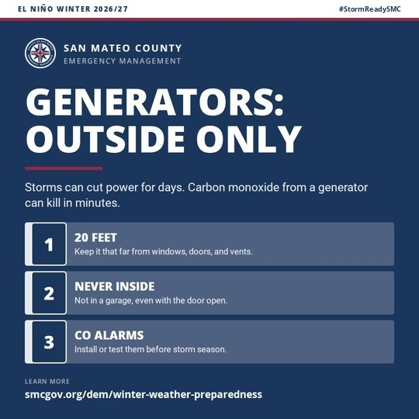 | Files: 15_generators_square.png, 15_generators_landscape.png  Alt text: Graphic from San Mateo County Emergency Management, El Niño Winter 2026/27. Headline: Generators: outside only. Storms can cut power for days. Carbon monoxide from a generator can kill in minutes. 20 feet: Keep it that far from windows, doors, and vents. Never inside: Not in a garage, even with the door open. CO alarms: Install or test them before storm season. Website: smcgov.org/dem/winter-weather-preparedness.
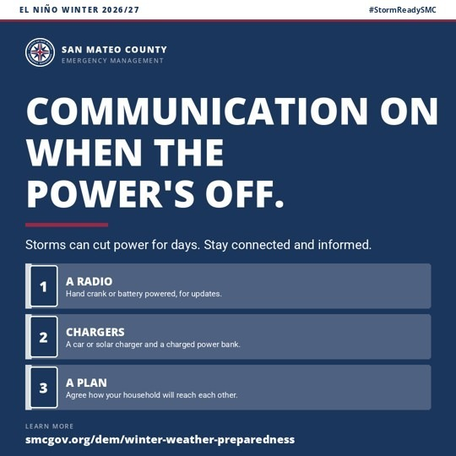 | Version B files: 15b_power_off_square.png, 15b_power_off_landscape.png  Alt text: Graphic from San Mateo County Emergency Management, El Niño Winter 2026/27. Headline: Communication on when the power's off. Storms can cut power for days. Stay connected and informed. A radio: Hand crank or battery powered, for updates. Chargers: A car or solar charger and a charged power bank. A plan: Agree how your household will reach each other. Website: smcgov.org/dem/winter-weather-preparedness.
Five Elements Check
Agency | Hazard and Impacts | Location | Protective Action | Time
[AGENCY] | Outages; carbon monoxide poisoning | [LOCATION] | Run generators outside only; keep a radio and chargers | This winter; during outages
Note: Version A (generators) runs with graphic 15; version B ("communication on") runs with graphic 15b. The version B line is adapted from FEMA's Ready.gov flood toolkit. Run version B first, before storms; save version A for the days before forecast wind storms and during outages.

16. Hillsides, Landslides, and Debris Flows
When | Before and after multiday or intense rain, especially once the ground is soaked.
Who posts | All partners serving hillside and canyon areas; fire and public works especially.
Audience | Residents on or below steep slopes and near creek canyons
Short Post (X, Bluesky, Threads)
[AGENCY]: Heavy El Niño rain can trigger landslides in [LOCATION]'s hills this winter. Watch for new cracks, tilting trees or fences, and creek water that turns muddy. If you see them, LEAVE. #StormReadySMC
206 characters as written (206 on X, where links count as 23).
Long Post (Facebook, Instagram, Nextdoor, LinkedIn)
[AGENCY]: Forecasters expect a very strong El Niño this winter. When heavy rain soaks the hills around [LOCATION], slopes can give way with little warning, and debris flows can move faster than you can run. If you live on or below a steep slope, or near a creek canyon, know the warning signs:
• New cracks in the ground, pavement, or walls
• Doors or windows that suddenly stick
• Tilting trees, poles, or fences
• Creek water that suddenly turns muddy or drops while it's still raining
• Rumbling or cracking sounds
If you notice these, LEAVE, and call 911 if anyone is in danger. Report road damage to [PUBLIC WORKS CONTACT]. #StormReadySMC
Graphic and Alt Text
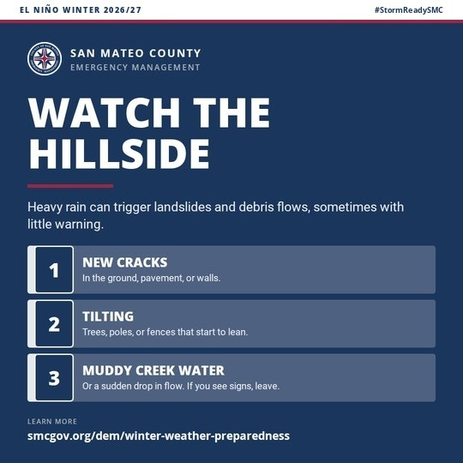 | Files: 16_landslides_square.png, 16_landslides_landscape.png  Alt text: Graphic from San Mateo County Emergency Management, El Niño Winter 2026/27. Headline: Watch the hillside. Heavy rain can trigger landslides and debris flows, sometimes with little warning. New cracks: In the ground, pavement, or walls. Tilting: Trees, poles, or fences that start to lean. Muddy creek water: Or a sudden drop in flow. If you see signs, leave. Website: smcgov.org/dem/winter-weather-preparedness.
Five Elements Check
Agency | Hazard and Impacts | Location | Protective Action | Time
[AGENCY] | Landslides and debris flows | [LOCATION]; steep slopes and canyons | Know the signs; leave | This winter; during and after heavy rain

Phase 4: After the Storm
As soon as each storm clears.

17. After the Storm: Stay Alert
When | As soon as a storm clears. Not a substitute for an All Clear alert.
Who posts | All partners.
Audience | Everyone
Short Post (X, Bluesky, Threads)
[AGENCY]: The storm has passed [LOCATION], but hazards remain. STAY AWAY from downed lines and anything touching them, avoid flood water, and REPORT damage to [PUBLIC WORKS CONTACT]. #StormReadySMC
197 characters as written (197 on X, where links count as 23).
Long Post (Facebook, Instagram, Nextdoor, LinkedIn)
[AGENCY]: The storm has moved on, but hazards in [LOCATION] haven't.
• STAY AWAY from downed power lines and anything touching them, including fences, puddles, and trees. Call 911, then PG&E.
• AVOID walking or driving through flood water. It can hide debris and broken glass, can carry oil, gasoline, and sewage, and can be charged by downed lines.
• WATCH roads where water has gone down. They may be weakened and can collapse under a car.
• HAVE a professional check a flooded home for loose wires, mold, and hidden damage before you move back in.
• RETURN home only when officials say it's safe.
• WATCH for weakened trees and slopes. Landslides can happen days after the rain stops.
• Take photos of damage before you clean up.
REPORT road damage and blocked drains to [PUBLIC WORKS CONTACT], and check on your neighbors. More storms may follow this El Niño winter, so restock your kit. #StormReadySMC
Graphic and Alt Text
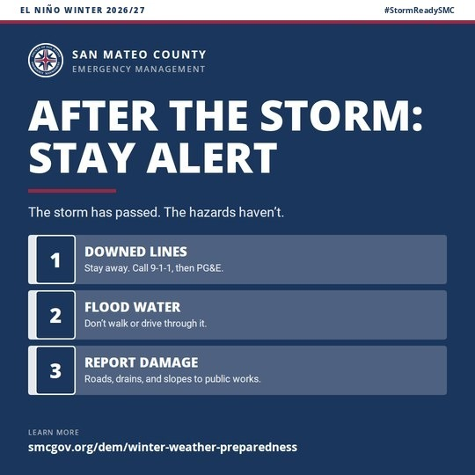 | Files: 17_after_the_storm_square.png, 17_after_the_storm_landscape.png  Alt text: Graphic from San Mateo County Emergency Management, El Niño Winter 2026/27. Headline: After the storm: stay alert. The storm has passed. The hazards haven't. Downed lines: Stay away. Call 9-1-1, then PG&E. Flood water: Don't walk or drive through it. Report damage: Roads, drains, and slopes to public works. Website: smcgov.org/dem/winter-weather-preparedness.
Five Elements Check
Agency | Hazard and Impacts | Location | Protective Action | Time
[AGENCY] | Downed lines, flood water, landslides | [LOCATION] | Stay away; report damage | After the storm; days after
Note: Alt text keeps "9-1-1" because that's how the number appears on the graphic.

Nixle
Many police departments, cities, and districts in the county reach residents through Nixle, and for some residents it's the only public safety channel they've signed up for. That makes Nixle part of one voice: the same words, the same links, and the same steps as everything else in this kit, plus a clear nudge toward SMC Alert.

How Nixle Fits With SMC Alert
Nixle and SMC Alert are separate systems with separate sign ups. A resident who gets your Nixle messages isn't automatically signed up for the county's storm, flood, and evacuation warnings. Every Nixle message in this kit reminds subscribers to sign up for SMC Alert too, and template N2 exists only to close that gap. Never suggest that a Nixle subscription covers county alerts.

Choose the Right Message Type
Nixle has 3 main message types, and choosing the wrong one costs subscribers. Nixle reserves the Alert type for urgent, must know notifications that only law enforcement or elected or appointed officials can authorize. Advisories carry important, need to know information that's less time critical, including weather. Community messages carry everyday news and nothing time critical. Nixle warns that overusing Advisories or Alerts raises the chance residents opt out.
Message type | Use it in this kit for | Never use it for
Community | Preparedness: N1, N2, N6 | Anything time sensitive
Advisory | Heads up before a known window or forecast storm: N3, N4, N5 | General preparedness tips
Alert | Nothing in this kit. Real, urgent warnings only, written from the Messaging Library | Preparedness, reminders, or sign up drives

What Subscribers Actually See
Under Nixle's SmartPath delivery, Advisory and Community messages go to a subscriber's email and the Everbridge mobile app, not to text, whenever the subscriber has an email address on file. Text goes out for those messages only to subscribers with no email on file, and text is capped at 160 characters. Alerts always go out by text, email, web, and push. In practice, most of your subscribers will read this kit's Nixle messages as email, so the subject line and email body do the real work, while the 160 character text reaches your text only subscribers. Every template below includes all 3.

Nixle Guidelines
Send no more than 1 preparedness message every 2 weeks outside of storm windows; the calendar spaces N1 through N3 with that in mind. Geotarget King Tides and hillside messages to the areas they affect rather than your whole jurisdiction. Keep the 160 character text version under that limit after you fill in placeholders, and put the link last so a cut off doesn't lose the action. When you promote your Nixle channel publicly, Nixle asks agencies to include its standard text message disclosure: how to get help, how to cancel, that message and data rates may apply, and that message frequency varies. Copy that wording from Nixle's support article on registering by text so it's exact.
N1. Get Storm Ready
Message type | Community
Target | Your full jurisdiction
Email subject | El Niño winter: 4 steps to take before the first storm
Text (160 characters maximum)
[AGENCY]: A very strong El Niño raises the odds of winter flooding. Get ready now: plan, kit, sandbags, SMC Alert. smcalert.info
128 characters with placeholders as written. Recount after you fill them in.
Email and web body
Forecasters expect a very strong El Niño this winter. That raises the odds of heavy rain, high tide flooding, and storm damage in [LOCATION]. It doesn't guarantee a stormy winter, and getting ready now pays off either way.
Take 4 steps before the first storm: MAKE A PLAN with your household, BUILD A KIT with 3 days of supplies, CHECK where to pick up sandbags, and SIGN UP for SMC Alert at smcalert.info.
Nixle brings you updates from [AGENCY]. SMC Alert is how San Mateo County sends storm, flood, and evacuation warnings for your address. They're separate, so please sign up for both.
More: smcgov.org/dem/winter-weather-preparedness
#StormReadySMC
N2. Sign up for SMC Alert too
Message type | Community
Target | Your full jurisdiction
Email subject | Nixle and SMC Alert are separate. Sign up for both.
Text (160 characters maximum)
[AGENCY]: Nixle and SMC Alert are separate. For county storm, flood, and evacuation warnings at your address, sign up at smcalert.info
134 characters with placeholders as written. Recount after you fill them in.
Email and web body
Thank you for following [AGENCY] on Nixle. This winter, please make sure you're also signed up for SMC Alert, San Mateo County's official system for storm, flood, and evacuation warnings.
SMC Alert sends warnings for your address by text, phone call, and email. Sign up or update your address and phone at smcalert.info. It takes about 5 minutes and it's free.
Then help 1 other person sign up.
#StormReadySMC
N3. King Tides
Message type | Advisory
Target | Geotarget shoreline, Bayfront, and coastal areas only
Email subject | King Tides [DATES]: expect water on low shoreline roads
Text (160 characters maximum)
[AGENCY]: King Tides [DATES]. Expect water on low shoreline roads near high tide. Avoid flooded roads; stay back from waves.
124 characters with placeholders as written. Recount after you fill them in.
Email and web body
King Tides, the highest tides of the year, reach [LOCATION] [DATES]. This winter, El Niño can push water even higher than predicted, and a storm at the same time makes it worse.
AVOID driving or walking through water on roads; it can hide damaged pavement. STAY BACK from the water's edge on beaches, bluffs, and jetties. MOVE cars out of low shoreline lots before high tide.
Local tide times: coastal.ca.gov/kingtides
#StormReadySMC
N4. Storm coming
Message type | Advisory
Target | Full jurisdiction, or the areas NWS highlights
Email subject | Storm expected [DAY/TIME]: do 3 things now
Text (160 characters maximum)
[AGENCY]: Strong storm expected [DAY/TIME]. Charge phones, clear the drain by your home, secure outdoor items. Updates: [URL]
125 characters with placeholders as written. Recount after you fill them in.
Email and web body
The National Weather Service expects a strong storm to reach [LOCATION] [DAY/TIME], bringing [HEAVY RAIN / STRONG WIND / HIGH SURF]. [LOCAL IMPACT].
Before it arrives: CHARGE phones and power banks, CLEAR leaves from the storm drain and gutters by your home, and SECURE outdoor furniture, trash bins, and anything the wind can throw.
If you live near a creek or on a steep slope, be ready to leave if told to. Make sure you're signed up for SMC Alert at smcalert.info. Updates: [URL]
#StormReadySMC
N5. Flooded roads
Message type | Advisory
Target | Full jurisdiction, before forecast heavy rain
Email subject | Your GPS doesn't know the road is gone
Text (160 characters maximum)
[AGENCY]: Heavy rain may flood roads [DAY/TIME]. Your GPS doesn't know the road is gone. If water covers it, don't drive in.
124 characters with placeholders as written. Recount after you fill them in.
Email and web body
Heavy rain may flood roads in [LOCATION] [DAY/TIME], especially near creeks and underpasses. Most flood deaths happen in vehicles.
6 inches of moving water can knock an adult off their feet. 12 inches can carry away most cars. You can't tell how deep water is, or whether the road under it is still there, especially at night.
If water covers the road, DON'T DRIVE IN. Find another route or wait it out, and never drive around barricades.
#StormReadySMC
N6. After the storm
Message type | Community
Target | Areas the storm affected
Email subject | The storm has passed. The hazards haven't.
Text (160 characters maximum)
[AGENCY]: Storm has passed, hazards remain. Stay away from downed lines, avoid flood water, report damage to [PUBLIC WORKS CONTACT]
131 characters with placeholders as written. Recount after you fill them in.
Email and web body
The storm has moved on, but hazards in [LOCATION] haven't.
STAY AWAY from downed power lines and anything touching them; call 911, then PG&E. AVOID flood water; it can hide debris and may be contaminated. WATCH for weakened trees and slopes; landslides can happen days after the rain stops. Take photos of damage before you clean up.
REPORT road damage and blocked drains to [PUBLIC WORKS CONTACT], check on your neighbors, and restock your kit. More storms may follow this winter.
#StormReadySMC
N7. Promote your Nixle channel (social post)
Post this on your own social channels during the week of Nov 2. It grows your Nixle list and SMC Alert at the same time.
[AGENCY]: Get local updates from us this winter: text [NIXLE KEYWORD OR ZIP] to 888777. For San Mateo County storm, flood, and evacuation warnings at your address, also sign up for SMC Alert at smcalert.info. They're separate, so sign up for both. #StormReadySMC
[NIXLE REQUIRED TEXT DISCLOSURE]

FEMA and Ready.gov Resources
FEMA's Ready.gov materials can run alongside this kit where they carry the same facts. Use them as companions to the #StormReadySMC graphics, not replacements, so residents still see one county campaign. Download graphics directly from Ready.gov, and always pair them with a post from this kit so the local action, link, and hashtag travel with them.
FEMA resource | Where to get it | Pair it with
National Preparedness Month 2026 graphics: Make a Plan, Plan Your Exit, Know Your Risk, Help Your Community, Stay Informed | ready.gov/collection/npm-2026-graphics | Make a Plan and Plan Your Exit with 03 and 18; Know Your Risk with 08; Help Your Community with 10; Stay Informed with 02
2026 National Preparedness Month partner toolkit and messages | ready.gov/2026-national-preparedness-month-partner-toolkit | Background copy for newsletters and 01; FEMA invites partners to customize it for local audiences
Flood insurance facts, including "Your Homeowners Insurance Does Not Cover Flood" | Listed with the flood resources on ready.gov/floods | 07 and 23
Ready.gov flood safety page | ready.gov/floods | 08, 13, and 17 as a "learn more" link
Commuter Emergency Plan (fillable PDF) | ready.gov/sites/default/files/2020-03/commuter_emergency_plan.pdf (open it before posting) | 18 and version B of 13
Flood Safety Social Media Toolkit | ready.gov/flood-toolkit | Source for the lines adapted in 03, 15, and 20; don't use its flooded roads posts

What to Skip
Ready.gov's flood and severe weather toolkits and its flood page still use Turn Around, Don't Drown. Don't use those posts or graphics, and don't pair the flooded roads posts (13 and 14) with FEMA flood graphics. Skip FEMA's illustrated flood graphics too; the cartoon style doesn't match this kit. Keep this kit's NWS definitions of watches and warnings rather than FEMA's looser shorthand, and point residents to SMC Alert rather than the FEMA app for warnings. National Preparedness Month graphics were built for September; they fit this season's readiness push, but drop them once storms begin and the kit moves into Storm Watch.

FEMA Messaging Worth Using
A few FEMA lines are solid and now appear in this kit's posts.
- Flooding doesn't follow lines on a map; where it can rain, it can flood (post 08).
- Keep password protected digital copies of important documents (post 04).
- Ask about backflow valves or a battery backed sump pump if water has reached your basement before (post 06).
- Barricades are there to get people out of flooded areas, stay off bridges over fast moving water, and stay inside a car caught in moving water, getting on the roof if water rises inside (post 13).
- Flood water can carry oil, gasoline, and sewage and can be charged by downed lines; roads where water has gone down can collapse; flooded homes need a professional check before anyone moves back in; and people should return home only when officials say it's safe (post 17).
- Don't go into flood water to evacuate, and if you're already on high ground, staying put may be safest (post 12).
- Turn on Wireless Emergency Alerts (post 02).
- FEMA estimates a few inches of water in a 1,000 square foot home could cost more than $10,000 (post 07).
- Pack a hand crank or battery radio and a car or solar charger (posts 04 and 15), and consider a basement water alarm (post 06).
- 3 FEMA hooks now lead posts: "Where will your loved ones be in a flood?" (03), "Get your communication ON when the power's OFF" (15), and "Don't let your business end up in a dumpster" (20).

Beyond Social Media
Social media reaches only some residents. These versions carry the same message into newsletters, websites, signs, radio, video, and conversations.

Newsletter or Website Blurb (about 120 words)
Get Storm Ready This Winter
Forecasters expect a very strong El Niño this winter. That raises the odds of heavy rain, high tide flooding, and storm damage in [LOCATION]. It doesn't guarantee a stormy winter, and getting ready now costs little and pays off either way. We know how to get ready for winter; this year, we start earlier.
Take 4 steps before the first storm. Make a plan with your household: where you'll meet and how you'll reach each other. Build a kit with water, food, medications, and copies of documents for 3 days. Find your nearest sandbag site. And sign up for SMC Alert at smcalert.info so storm and flood warnings reach you at your address. Already signed up? Check that your information is current.
Learn more: smcgov.org/dem/winter-weather-preparedness

Digital Signs and Reader Boards
Use 3 short lines, each under 20 characters, and rotate them in this order all season.
STORM SEASON AHEAD
GET STORM READY
SMCALERT.INFO

Radio or Video Script (30 seconds, about 75 words)
This is [NAME] with [AGENCY]. Forecasters expect a very strong El Niño this winter. That raises the odds of heavy rain and high tide flooding here in San Mateo County. We know how to get ready for winter. This year, start earlier. Make a plan with your household. Build a kit with 3 days of supplies. Find your nearest sandbag site. And sign up for SMC Alert at smcalert.info. Get storm ready, starting today.
For video, show the speaker on location in your community, caption every word, and end on the Get Storm Ready graphic.

Outreach Script for CBOs and Outreach Staff/Volunteers
For conversations with people who may not see alerts or posts, including residents staying in vehicles, RVs, or near creeks, farmworkers, and people without reliable phone service. Say it in your own words and in the person's language.

"This winter could bring more storms than usual. When it rains hard, creeks can rise fast, especially at night. If it's raining hard and you're near a creek or in a low spot, move to higher ground early. Don't wait for the water.
If you have a phone, even a prepaid one, you can sign up for free county warnings at smcalert.info. I can help you do it right now.
If you need somewhere to go during a storm, here's who to call: [LOCAL RESOURCE]."

Handoff to the Alert and Warning Messaging Library
This toolkit covers the time before and after storms. When a hazard is active or NWS issues a warning, stop preparedness posting for the affected area, on social and on Nixle, and use the Messaging Library template instead. Library templates start with "SMC Alert:"; keep that prefix for alerts only. If you send on Nixle during an active hazard, use the Alert type and the Library's wording.

When this happens | Use this Messaging Library template
NWS Flood or Flash Flood Warning, or flooding is occurring | Flood/Flash Flood
NWS High Wind Warning, or damaging winds are occurring | High Wind
NWS severe storm warning | Severe Storm
A landslide is reported | Landslide
A mud or debris flow is reported | Mud/Debris Flow
Widespread outages or a PG&E Public Safety Power Shutoff | Power Outages; PG&E PSPS Event
A road is closed by flooding, a slide, or downed trees | Road Closure
People need to get ready to leave, or leave now | Evacuation Warning; Evacuation Order
A levee fails or is threatened | Dam/Levee Failure
The threat is over | All Clear

Graphics Index
All graphics are PNG files in the graphics folder. Square (1080 by 1080) works on Facebook, Instagram, and Nextdoor. Landscape (1200 by 675) works on X, Bluesky, and link previews. Every graphic carries the El Niño Winter band in navy and white and #StormReadySMC so the series reads as 1 campaign. Garnet appears only as an accent, like a rule or frame, and never on words.
# | Topic | File name (add _square.png or _landscape.png)
01 | El Niño Winter: Get Storm Ready | 01_get_storm_ready
02 | Sign Up for SMC Alert (and Update Your Info) | 02_smc_alert
03 | Make a Plan | 03_make_a_plan
04 | Build a Kit | 04_build_a_kit
05 | Pick Up Sandbags Early (HOLD) | 05_sandbags
06 | Clear Gutters and Storm Drains | 06_clear_drains
07 | Check Your Flood Coverage | 07_flood_insurance
08 | Know Your Flood Risk (New Residents) | 08_flood_risk
09 | Plan for Extra Help (Older Adults and People with Disabilities) | 09_extra_help
10 | Check on Each Other | 10_check_on_neighbors
11 | King Tides and Coastal Flooding | 11_king_tides
12 | Storm Coming: Do 3 Things Now | 12_storm_coming
13 | Flooded Roads: Your GPS Doesn't Know the Road Is Gone | 13_flooded_roads
13b | Flooded Roads: Nobody Plans to Drive Into a Flood (version B) | 13b_get_home
14 | Flooded Roads: Flood Water Totals Cars (Young Drivers) | 14_not_worth_it
15 | Power Outages and Generator Safety | 15_generators
15b | Communication On When the Power's Off (version B) | 15b_power_off
16 | Hillsides, Landslides, and Debris Flows | 16_landslides
17 | After the Storm: Stay Alert | 17_after_the_storm
18 | Coastside: Plan for Closed Roads | 18_coastside_roads
19 | Check Your Trees | 19_trees_wind
20 | Businesses: Don't Let Your Business End Up in a Dumpster | 20_business_ready
21 | Families and Schools: School Day Storm Plan | 21_families_schools
22 | Pack a Pet Go Bag | 22_pets_ready
23 | Record Your Stuff | 23_record_your_stuff
24 | Before the First Storm: Check These 4 (portrait only) | 24_check_these_4_portrait.png
 | Printable flyer (letter size) | Get_Storm_Ready_Flyer.pdf
 | Printable flyer, Check These 4 (letter size) | Check_These_4_Flyer.pdf
The SMC Alert QR code on graphics 01 and 02 and on the flyer was generated for https://smcalert.info and tested before release. Translated graphics will follow with the translated copy.

