March 10, 2025

Present: Alfred Banfield, Donna Vaillancourt, Carolyn Schlocker, Mary Cravalho, Ben Suncin

Staff: Ed Kiryczun, Alex Ayag, Samay Chhun

Public Comments By: Don Pugh and John Helin

Topic | Discussion | Actions/Next Steps
Meeting called to order & Pledge of Allegiance Recited | - Meeting called to order at 6:40 pm  - Pledge of allegiance and roll call taken – 5 present | No Additional actions or steps
Approval of minutes & adoption of agenda | - No approval to set Agenda or Minutes  - Quorum for March 10 commission board meeting not met | No Additional actions or steps
Public Comments | Don Pugh  - Wanted confirm registration again for Veterans wanting to sign up is due by March 30th  - Alex already put flyer on website and in office for any Veterans who are interested | No additional actions or steps
Veterans Commission Business | Ed Kiryczun, VSO Operation Update  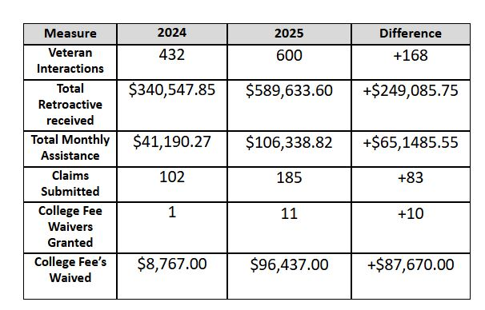  - Jaime from VA healthcare asking anyone interested in attending the 44th annual speedster event.  - Happening on June 6th from 8am until 4pm at VA Palo Alto Campus  - SMC Veterans commission is invited to table along side Santa Clara Veterans commission.  - Update: Next Commission meeting will be held in Downtown Redwood City—Parking maps and building location will be provided once invite is sent out | No Additional actions or steps

Topic | Discussion | Actions/Next Steps
Veterans Commission Business (Continued) | Alex Ayag VSO Operation Update  - Save the date flyer for provider event link is live and emailed to last year participants.  - Database for service providers—currently excel form.  - VA Palo Alto does have an employment service for Veterans—Ed can bring up in the next meeting.  - In terms of Funding—County Veteran office does not depend on Federal funding.  - No rumors yet as to any cuts for veterans benefits other than delayed process for claims | No Additional actions or steps
Veterans Commission Business (Continued) | Legislative: No updates  Mental Health Support: No updates  Housing and Homelessness: Ben Suncin  - Meeting with Nick and Trevor  - Went into detail about BMR again for Veteran Preferences  - Want to talk with SMC housing department on how the program can work for Veterans living within San Mateo County  - Had a meeting with Brooke Stacey who works for Center of Homelessness  - Want to know the Rate of recidivism of Veterans that does get sheltered how much goes back to being homeless—Will try to get updates on percentages. | No Additional actions or steps
Veterans Commission Business (Continued) | Donna Vaillancourt  - Reminder: Annual service provider luncheon date set on April 24, 2024  - Location will be at the San Mateo Elks Lodge  - Expecting up to 140 providers—details with any brochures or flyers the providers want to bring will be placed at a separate table.  - Standalone meeting with the organizers has been set for follow-ups via Zoom | No Additional actions or steps
Adjournment | - Meeting adjourned at 7:15 pm  - Adjourn approved 5 Y/ 0 N

