January 13, 2025

Present: Alfred Banfield, Donna Vaillancourt, Fred Baer, Brandon Jones, Stan Maupin, Mary Cravalho, Carolyn Schlocker, Keith Darby, Ben Suncin

Staff: Ed Kiryczun, Alex Ayag, Samay Chhun

Public Comments By: Don Pugh and John Helin

Topic | Discussion | Actions/Next Steps
Meeting called to order & Pledge of Allegiance Recited | - Meeting called to order at 6:30 pm  - Pledge of allegiance and roll call taken – 9 present | No Additional actions or steps
Approval of minutes & adoption of agenda | - Minutes November 18, 2024, approved 9 Y/ 0 N  - Call to set Agenda approved 9Y/ 0 N | No Additional actions or steps
Public Comments | Don Pugh  -60 rides in Lava Lake at Jasper Ridge back country in Montana.  -Currently looking for funding 4 Vets at a time to ride horses at the Ridge.  -This is a form of therapy for Veterans who wants to get into equestrian.  -Funding cost will need $13K--Horses for Hero’s  John Helin  -Christmas luncheon will happen Friday before Christmas December 19, 202  -Goal: Provide bus to pick up Vets possibly at Veteran Village | *Alex adding link to website on how people could donate  *Will let Alex know once an event will happen
Veterans Commission Business | Ed Kiryczun, VSO Operation Update  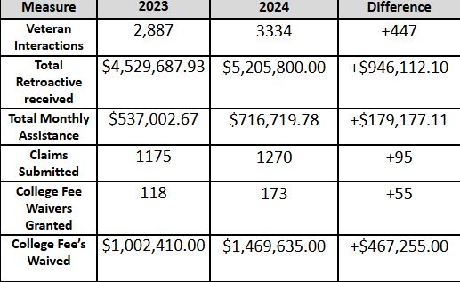  - Reminder of the Provider Network Event happening in April  - Veterans Stand down: if you would like to participate in the workgroup, let Alex know.  - 2025 Veteran of the New Event – Will be working with Marci and the new Supervisor on this.  Alex Ayag Outreach Updates  - 2024 Website Most Visited links are college fee waivers, how to file claims and announcements.  - 2025 Effort is to expand to more libraries in Millbrae, SSF and Pacifica  - Getting out newsletter quarterly  - Hosting another Veterans Career Fair with HR | No Additional actions or steps

Topic | Discussion | Actions/Next Steps
Veterans Commission Business (Continued) | Ben Suncin  Laurie Personal Statement on Veteran Services  - Personal experience with homelessness and getting help with different resources for Veterans.  - Didn't address her problems in the military until later in life.  - Masked PTSD by working long hours.  - Though there are resources for housing, healthcare, food, etc.; there should be more resources available for storage, car rentals, furniture, etc. | No Additional actions or steps
Veterans Commission Business (Continued) | Veterans Affair Employment Coordinator Presenters  David Rice, Emilia Gaytan and Ryan Bacon  - Main purpose is to work with Vets to transition into housing.  - Community partners- create opportunities for Vet.  - Work with vet who is currently in transition and not in therapy.  - 2 outreach events every Monday and CWT program referral  - Help with job search technique and interview skills.  - Workshops on training resources and volunteer opportunities | No Additional actions or steps
Veterans Commission Business (Continued) | Legislative- Keith Darby and Aditi Patel  - Three different pieces of Legislative in 2025-2026 in support of Veterans  - Bill that didn't pass last year and coming back is retirement tax exemption.  - AB-53 (Ramos & Pacheco) – Personal Income Taxes: exclusion: Military Services Retirement and Surviving Spouse Benefit Payment Act (https://leginfo.legislature.ca.gov/faces/billTextClient.xhtml?bill_id=202520260AB53)  - SB-1 (Seyarto) – Personal Income Taxes: exclusion: Military Services Retirement and Surviving Spouse Benefit Payment Act (https://leginfo.legislature.ca.gov/faces/billNavClient.xhtml?bill_id=202520260SB1)  - SB-23 (Valladares & Grove) – Property Taxation: exemption: disabled veteran homeowners (https://leginfo.legislature.ca.gov/faces/billTextClient.xhtml?bill_id=202520260SB23)  No updates on Mental Health- Brandon Jones and Mary Carvalho  Housing/Homelessness-Stan Maupin and Kyle Corcoran  - Nick and Trevor from San Francisco Commission in relation to Veterans housing preferences, will be meeting with sub-committee to address BMR in San Mateo County  - Tunnels to towers intermediate housing through combat (future meeting to discuss location)  - 11/11 Lodge is a new site by life moves open on December 2nd, 2024  - Currently there are 39 rooms available under VA contract. Looking to add more rooms  - At least 90 days stay minimum | No Additional actions or steps
Veterans Commission Business (Continued) | Donna Vaillancourt  - Annual service provider luncheon date set on April 24, 2025  - Location will be at the San Mateo Elks Lodge  - At least 150 service providers expected.  - Working with Alex to send email out for Save the Date  - Currently process in determining funding and other resources that may be needed | No Additional actions or steps
Adjournment | - Meeting adjourned at 7:56 pm  - Adjourn approved 9 Y/ 0 N

