Monday September 9, 2024

Present: Donna Vaillancourt; Ben Suncin; Fred Baer; Keith Darby; Mary Carvalho; Brandon Jones; Al Banfield; Stan Maupin
Staff: Ed Kiryczun, Marci Dragun; Samay Chhun; Alex Ayag; John Nibbelin
Public Comments By: None

Topic | Discussion | Actions/Next Steps
Meeting called to order & Pledge of Allegiance Recited | - Meeting called to order at 6:30 pm  - Pledge of allegiance  - Roll call taken – 8 present/ 6 absent.  - Swearing in of New Commissioner Ben Suncin | No Additional actions or steps
Approval of minutes & adoption of agenda | - Minutes from July 8, 2024, Commission meeting adopted.  - Minutes Approved 8 Y/0 N  - Agenda Approved 8 Y/0 N | No Additional actions or steps
Public Comments | John B- Formal Introduction to commissioner who meet Mary Carvalho at county meeting | No Additional actions or steps
Veterans Commission Business | Ed Kiryczun, VSO Operation Update  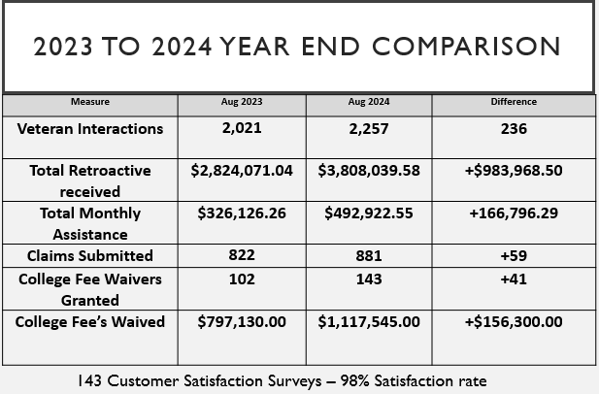  - VA has been experiencing a 1–3-week backlog on most submission across their systems.  - $15 billion emergency bill was introduced to address the VA shortfall for the remainder of the year.  - June 26, 2024; Presidential Proclamation on certain violations grants full and unconditional pardon to individuals with court-martial convictions under former article 125. | No Additional actions or step

Topic | Discussion | Actions/Next Steps
Veterans Commission Business (Continued) | Veteran of the year luncheon update  Stan Maupin  - Veteran of the year: Bob Hoover  - Enterprise of the year: San Mateo Elks Lodge #1112  - Patriot of the year: Congress Women Anna Eshoo  - Lifetime achievement: Supervisor Warren Slocum  - November 8th Veteran of the Year Luncheon 11:40 am- 1:30 pm  - Keynote Speaker: Retired Ann Rondeau-president of post naval graduate school.  - Currently 30 seats available to Veterans maybe more with more sponsors | No Additional actions or steps
Veterans Commission Business (Continued) | Commissioner Updates  Brandon Jones Introduction of Vietnam Vet Don Pugh  - Don Pugh Vietnam Veteran-Even with the expansion of PACT ACT not all condition is part of the presumptive list due to exposure of Agent Orange  - Challenging experience with VA healthcare when he first started treatment for cancer.  - Surprised Pancreatic cancer is not recognized as a causation of Agent Orange exposure.  - Doing more research with VA and Stanford Medical Doctors and study to have Pancreatic Cancer added to presumptive list as a probable cause as Agent Orange Exposure  - Hope to take evidence of study to the VA to make changes to PACT ACT and expand presumptive. Having medical study done is having medical based evidence presented. | No Additional actions or steps

 | Topic | Discussion | Action/Next Steps
 | Veterans Commission Business (Continued) | Legislative Updates – Keith Darby, Aditi Patel and Corey Braddock  Keith Darby  - 2 specific impact revision to governor state budget not heavily impact essential services to Veterans.  - Added more 6.3 billion from prop 1. A lot of the funding will go towards homelessness and adding more housing.  - Takeaway in prop 1 is adding more money assisting Veterans who are homeless.  - AB 11746 was not passed or has been rejected.  - 7 legislation that is still moving forward towards next step regarding Veterans | No Additional actions or steps
Veterans Commission Business (Continued) |  | Mental Health Support- Brandon and Mary Carvalho  - July Suicide awareness month  - Brandon attended Alameda County Standdown  - Santa Clara Veteran stand down begins October 2-4 at Santa Clara County Fairgrounds  Housing and Homelessness Updates-Stan Maupin and Kyle Corcoran  - Meeting with Ed tunnel to towers veteran village concept.  - Services in between with Vet who are mobility challenging to redo entire house as well as first responders.  - Want to start the process soon and get a meeting with the board of supervisors.  Updates: Donna Vaillancourt  - Next meeting to go over strategic planning and what was done so far this year that was originally planned.  - Planning on November 18, 2024 | No Additional actions or steps
Adjournment |  | Meeting adjourn at 7:35 pm | No Additional actions or steps

