Present: Alfred Banfield, Hank Scherf, Donna Vaillancourt, Caroline Schlocker, Fred Baer, Cody Stephenson, Brandon Jones, Mark McVay, Mary Cravalho

Staff: Ed Kiryczn, Selina Toy Lee, Samay Chhun, Alex Ayag

Public Comments By: None

Topic | Discussion | Actions/Next Steps
Meeting called to order & Pledge of Allegiance Recited | - Meeting called to order at 6:30 pm  - Pledge of allegiance and roll call taken – 9 present  - New Full Member Oath of Office | No Additional actions or steps
Approval of minutes & adoption of agenda | - Minutes from May 8, 2023, commission meeting was adopted  - March 13, 2023, Veterans Commission meeting agenda was adopted  - Proposal to adopt AB 46 and SB 726  - Minutes approved 9 Y/ 0 N  - Agenda approved 9 Y/ 0 N | No Additional actions or steps
Public Comments | None | No Additional actions or steps
Veterans Commission Business | Ed Kiryczun, VSO Operation Update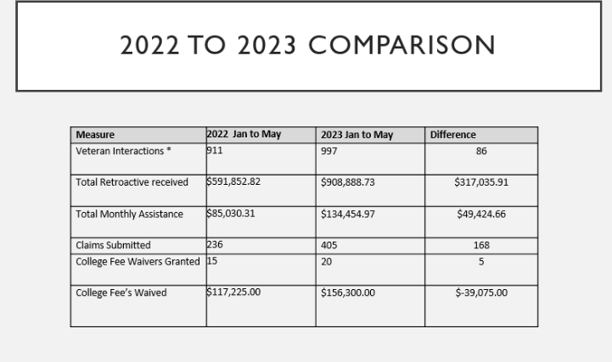 | No Additional actions or steps

Topic | Discussion | Actions/Next Steps
Veterans Commission Business (Continued) | Ed Kiryczun, VSO Operation Update  - July Meeting has been switched to 7/17  - SAVES training and Veterans Resource Panel: Held at Redwood City Library on Tuesday May 16th at 5:30  - Veterans of the Year Event nomination links will be sent out  - Save the Date: May 29th, Memorial Day Golden Gate National Cemetery  - California Disable Veterans License Plate Program: AB 2949 grants eligible veterans of the US armed forces free tolls on California bridges and toll highways starting January 1, 2023  - To include Congressional Medal of Honor, Disable Veteran, Pearl Harbor Survivor, Ex Prisoner of War and Purple Heart designation  - DV plates requires as a result of disease or injury incurred in services; has 100% disability rating due to diagnosed disease/disorder that impairs mobility, has lost use of one or more limbs, suffered permanent blindness | -Samay will send updated invites for commission meeting on July 17
Veterans Commission Business (Continued) | Vince Cantore/Jennifer Wood (Millbrae Gateway Project Update)  - Approximately 75+units available to Veterans  - Getting more units available for Veterans and their family  - Veterans come apply but often they do not follow up and we don’t know why  - Hoping that the commission and or VSO office can navigate how we can follow up with Veterans who is wanting to apply at Millbrae  - There are some hiccups with the application process and Veterans don’t have the necessary paper or documents  - Looking for ways to improve the qualifying process to get Veterans into those units  - Current units occupied currently by Vets are studios and 1-bedroom apartments. 2 or more rooms are limited

 | Topic | Discussion | Action/Next Steps
 | Veterans Commission Business (Continued) | Shirley Chu BHRS  - Community Wellness and Crisis Response Team (CWCRT) and San Mateo Mental Health Assessment & Referral Team (SMART)  - Partnership with Police Depts, SMC BHRS, Star Vista  - Service Areas: Daly City, San Mateo, S. San Francisco, Redwood City. Operation hours are M-F 9-6  - Scope: All ages, crises involving mental health issues regardless of insurance, legal and veteran status  - Immediate goals: Stabilize crisis, connect to needed resources, positive outcomes  - Long term goals: Reduce psych hospitalization, reduce criminal justice involvement, and improve crisis response  - Contracted with American Medical Response to conduct crisis assessment and transport  5150 evaluation and apply 5150 involuntary holds for DTS, DTO and GD | No Additional actions or steps
Veterans Commission Business (Continued) |  | Donna Vaillancourt  - Proposal on Legislative Update and action to adopt resolutions requesting San Mateo County Board of Supervisor to support AB46 and AB 726  - 9 Y/ 0 N  - Veterans Commission Recruitment Closed. June meeting will be interviews  - Sub committee meeting will be discussed in July 2023 Meeting | No Additional actions or steps

Adjournment | Meeting adjourns at 8:10 pm

