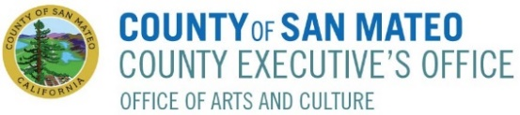

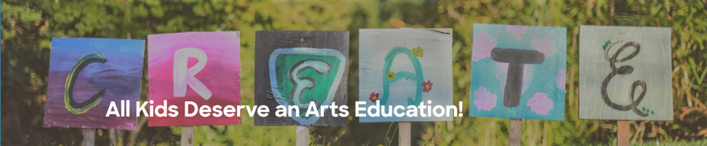

Do you want to bring more Arts and Culture experiences
to your students? We can help you with that!

The San Mateo County Office of Arts and Culture (OAC) is pleased to partner with Dragonfly Community Arts to provide an Educator Microgrant Arts Program. Grants will support and encourage educators in San Mateo County K-12 Title I schools to bring more arts and culture into their classrooms. The grant cycle will be open from Sept. 23 – Oct. 14. Grant awards will be issued by October 21, 2022.

And the best part about the program, it’s easy to apply and participate. Guidelines:
- K-12 teachers in San Mateo County Title I schools are eligible to apply
- Grants in the amount of $200 each will allow teachers to use funds for either:
- art materials or musical instruments; or
- performances, workshops, or art experiences
- Grants will be awarded to a single teacher or teachers may apply together and must be used by May 31, 2023
- Applicants must have approval from their school principal to apply
- First come, first served up to 80 applications and after that will be added to wait list.

To apply for art materials and musical instruments:
Teachers create a project on DonorsChoose.org up to $200, send the project link to artsandculture@smcgov.org and will then be awarded the grant through the DonorsChoose.org.

To apply for performances, workshops, or art/culture experiences:
Teachers will select programming from a menu of organizations and programs (including music, dance, visual arts, literary arts, and humanities) and apply for a grant through a short online application. Participating arts resources:

- Art in Action
- Casa Circulo Cultural
- InkFlow Communications
- Mannakin Theater & Dance/en Avant School
- Music at Kohl Mansion
- Quinteto Latino
- Peopleologie
- The Beat Within
- ZiRu Dance

Email questions to: artsandculture@smcgov.org

“We believe arts programming and education should be accessible to all people regardless of age, geographic location, identity, or socio-economic background. When art is accessible to everyone, all voices are heard. And when our voices are heard, we can contribute to a better community and a better world.”
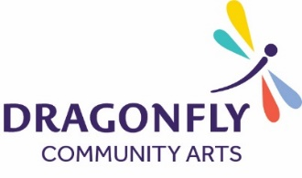
Dragonfly Community Arts

